CAB230 Assignment 2 Client Side
n11272031 |12/05/2023
CAB230 – Movie API Client Side Application

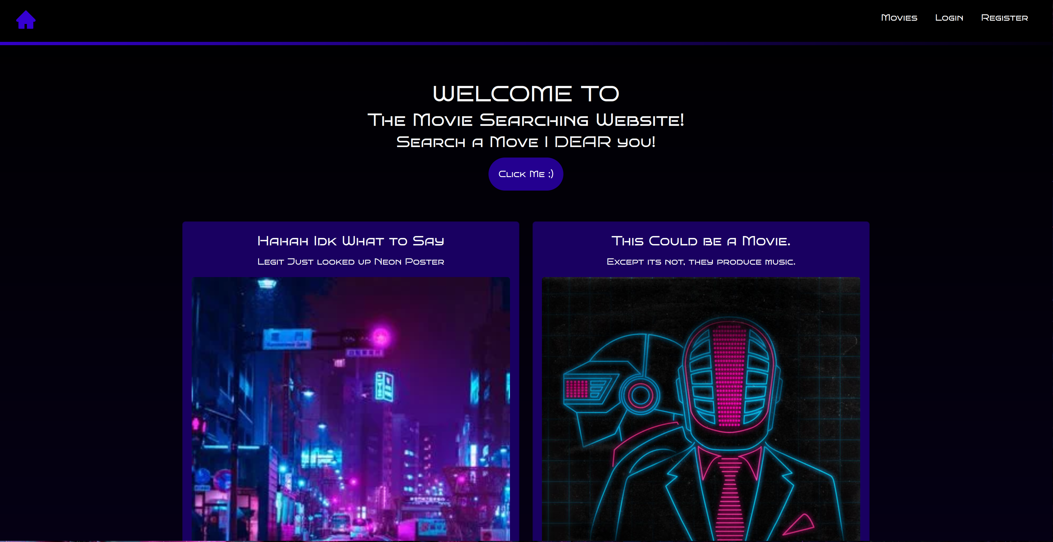

Contents
Introduction 3
Purpose & description 3
Completeness and Limitations 4
Use of End Points 5
/movies/search 5
/movies/data/{imdbID} 5
/people/{id} 6
/user/register 6
/user/login 7
/user/refresh 7
/user/logout 7
Modules Used 8
Ag-grid-react 8
Reactstrap 8
Chart.js 8
MUI 8
Application Design 9
Navigation and Layout 10
Usability and Quality of Design 12
Accessibility 12
Technical Description 13
Architecture 13
Test plan 14
Difficulties / Exclusions / unresolved & persistent errors 15
User guide 16
References 19
Appendices 20

Introduction
Purpose & Description

A movie searching website is designed with the purpose of allowing users to search and discover information about movies in a convenient and efficient manner. The website typically provides various search options, such as title, and year, to assist users in finding the movies they are interested in. The website may also offer ratings, to help users make informed decisions about which movies to watch. The primary objective of a movie searching website is to provide a comprehensive database of movies to users, allowing them to search, browse, and discover movies and related information.

I included the functionality of when a user in registering to the website it not only registers the user but logs them into the website with out needing to go to a different page and get the user to put there login credentials. This is a small and subtle change but I feel makes the experience more seamless and coherent for the user and more likely to stay on the site.

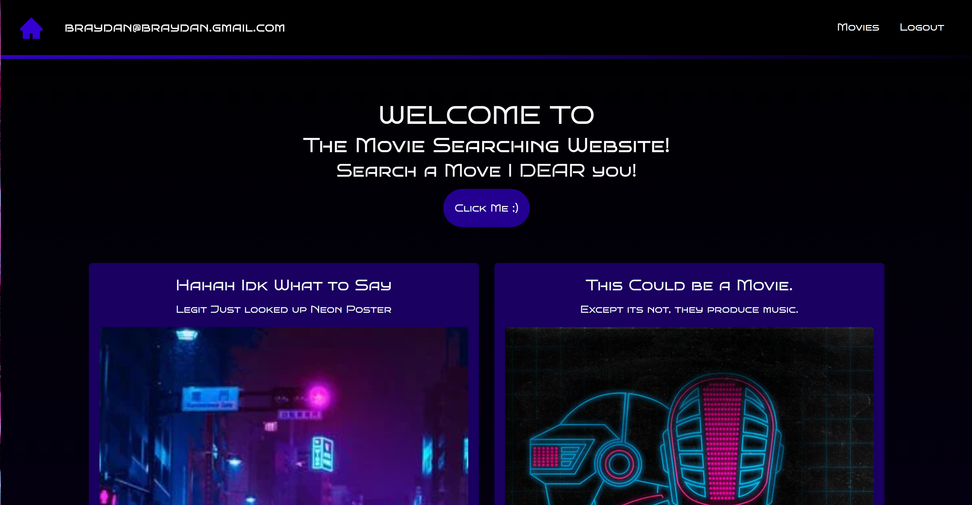
In a website that will have a far amount of information on it I’m looking for a website to consider eye strain by making it a dark theme and pleasing to look at. Reading on a bright background can cause eye strain and even headaches, especially for those who spend long hours in front of a screen. A dark theme on websites can reduce eye strain, as it produces less glare and is easier on the eyes. A website dark theme can offer several potential benefits, including reducing eye strain, saving battery life, enhancing readability and aesthetics.
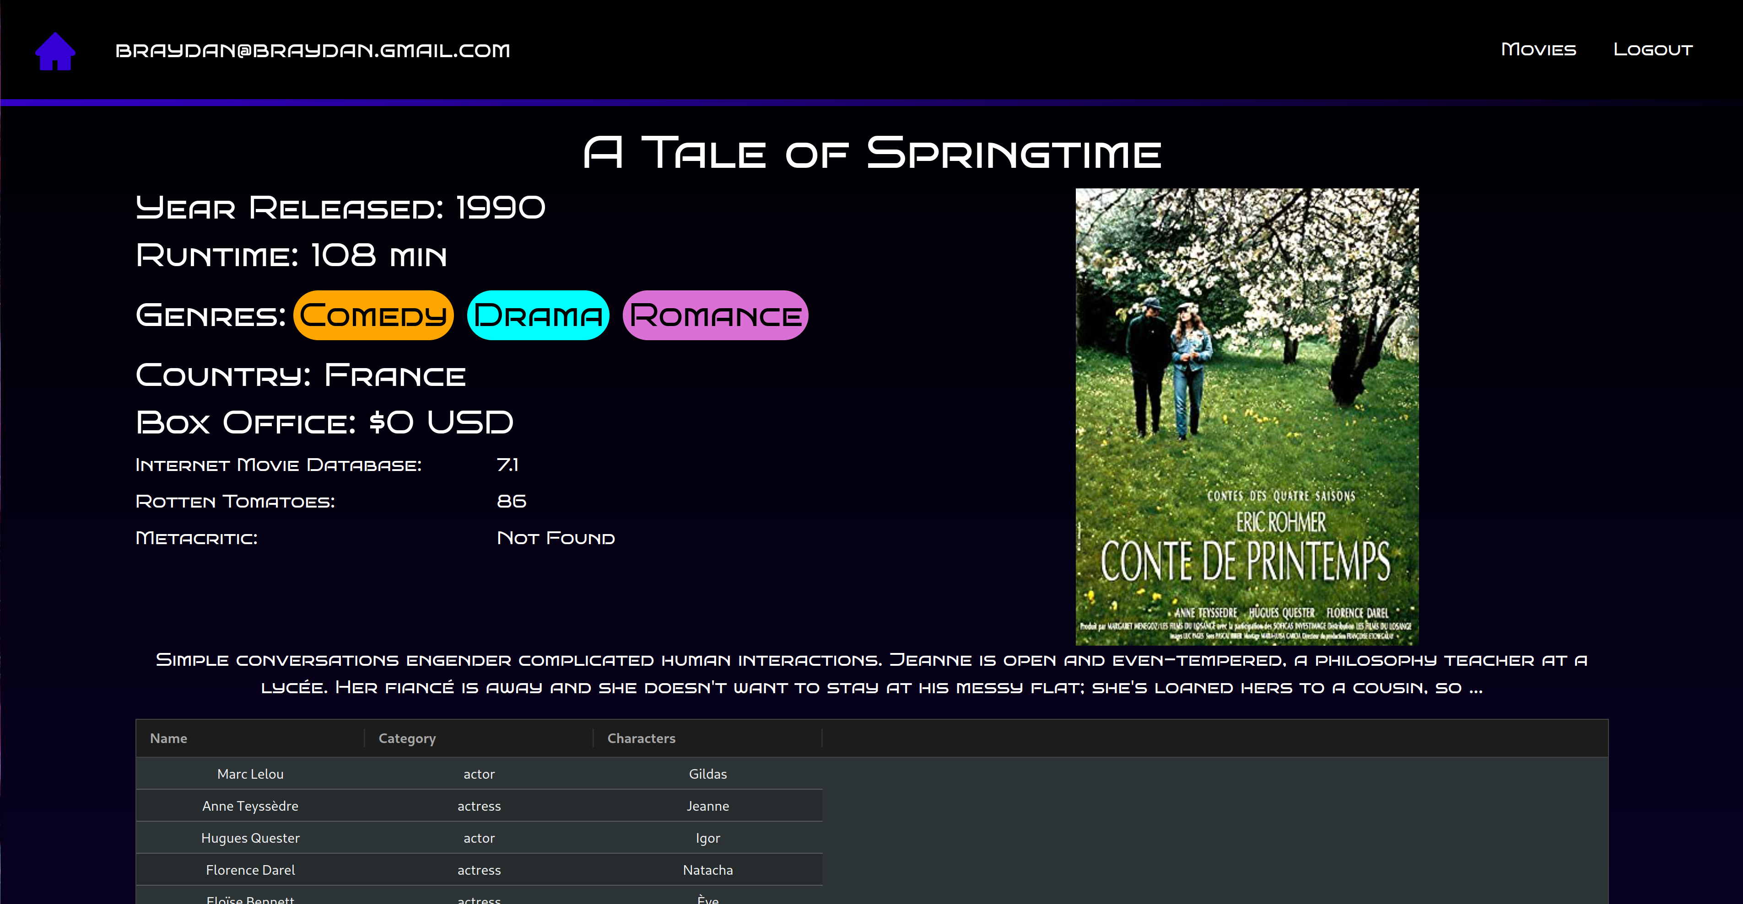
Completeness and Limitations

I completed all but 1 – 2 of the requirements which is paginated and infinite Scrolling on the Movie List page due to a lack of time. All other features are implemented along with no excessive querying
of the server while retaining feature parity. In addition I try to increase the user experience by reducing the amount of time a user needs to input there authentication details while registering and logging in. This is by logging the user in straight away after registering no second page. The chart data is present for the IMDB scores in People’s data however the Ag grids do have some formatting issues. All authentication with refresh tokens is added, this works by cheeking the response from a authenticated endpoint and if it has expired it attempts to refresh from there the relevant page is shown. Id like to say the code is laid out well along with the folder structure and my use of callback function allows for better navigation and readability.

Use of End Points
/movies/search
This endpoint allowed for the search of movies in the data base while also allowing filtering for year and title containing text
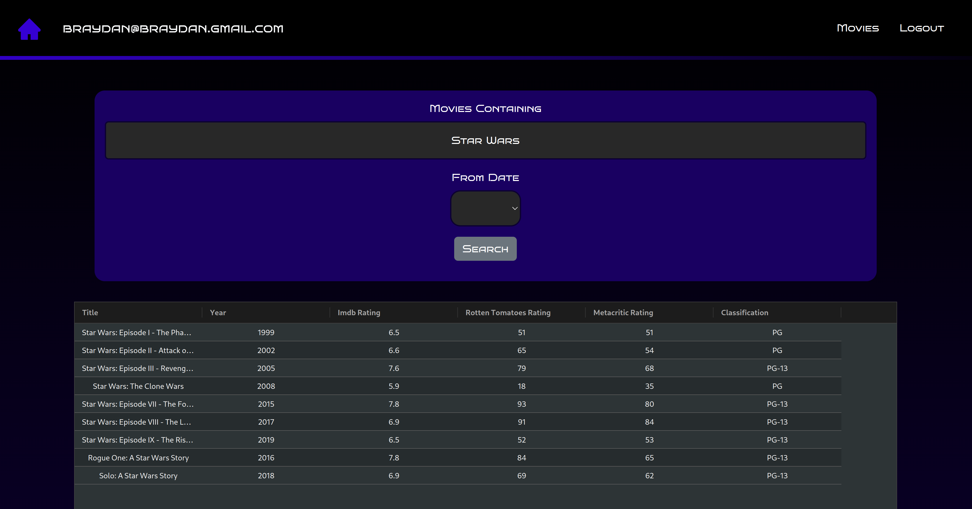

/movies/data/{imdbID}
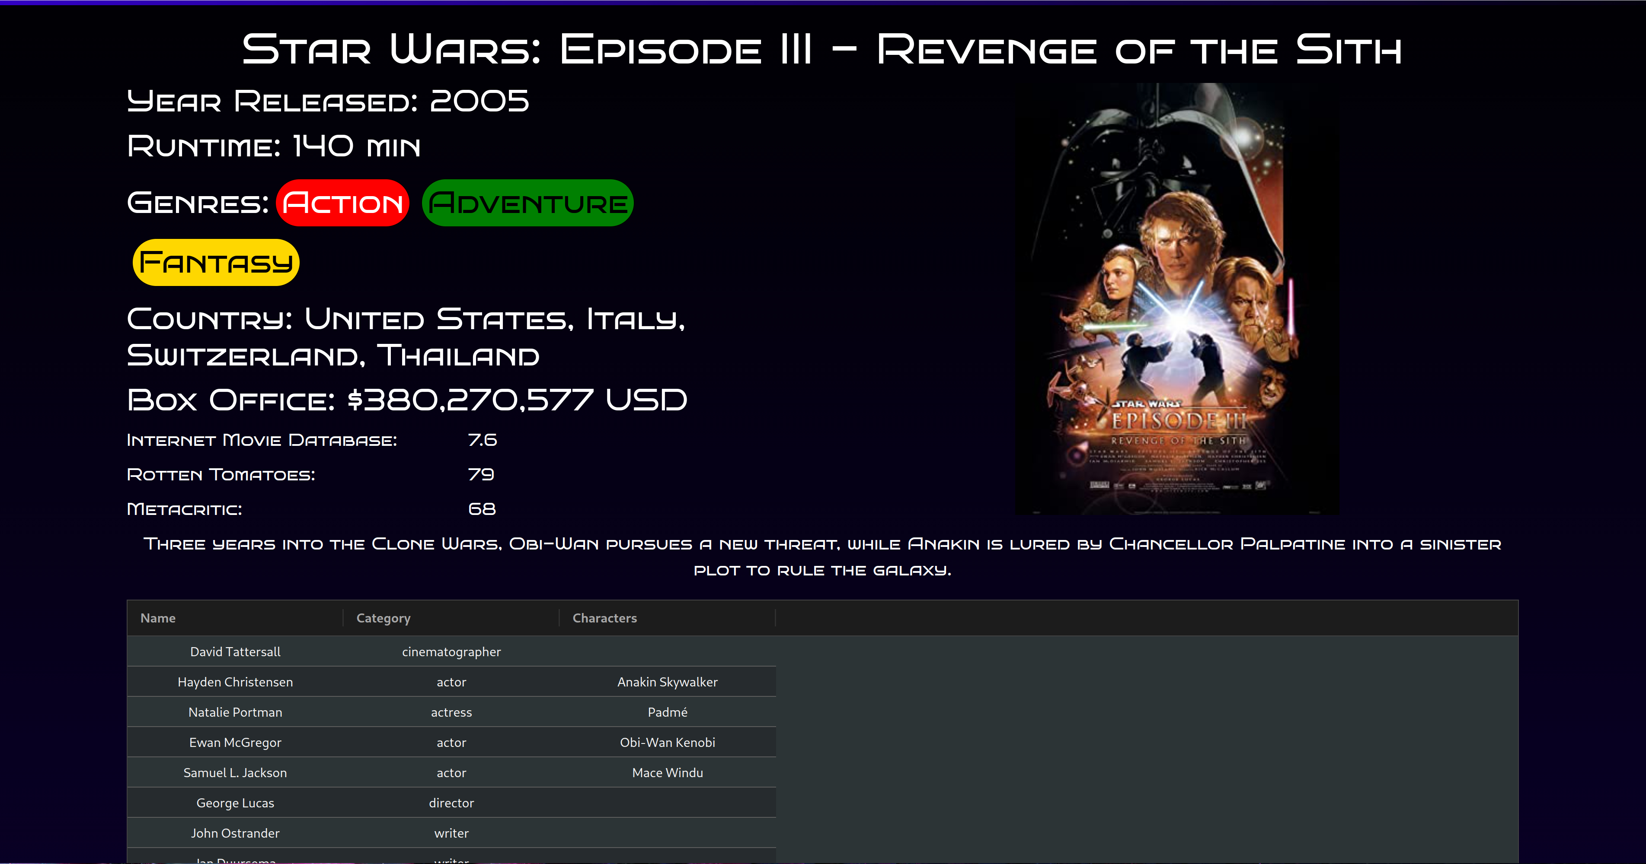
This endpoint allows an ID of a specific movie to get extra information about it

/people/{id}
This endpoint allows an ID of a specific person to get extra information about them
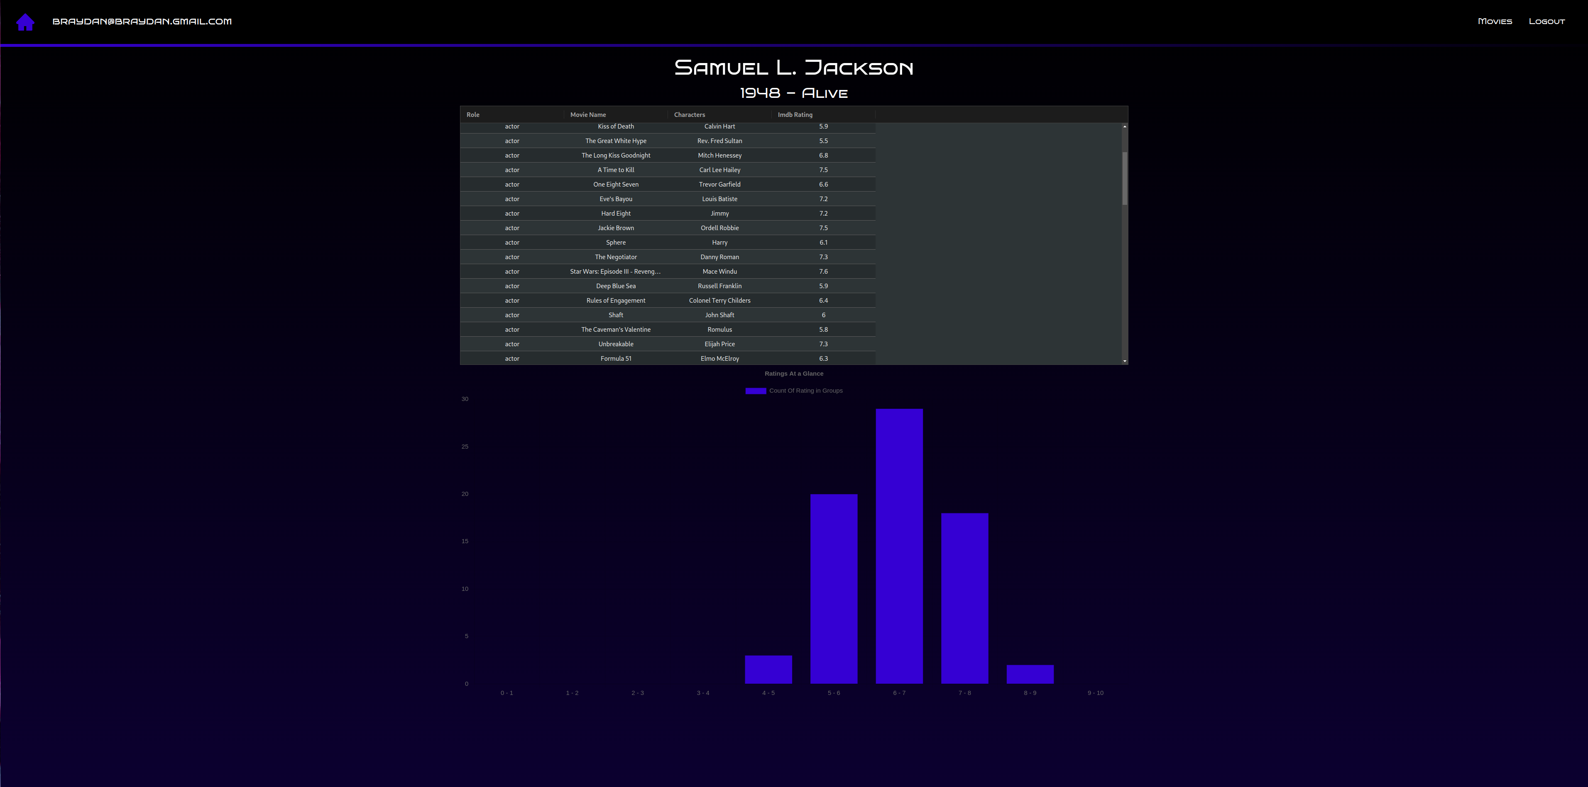
/user/register
This endpoint allows for a user to register an account on the site for further features
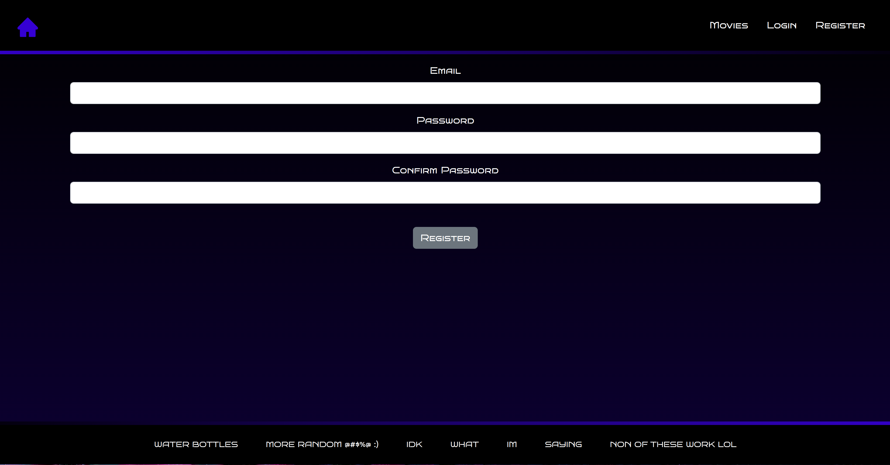

/user/login
This endpoint allows for a user to login to an already registered account on the site to access data be hind authentication
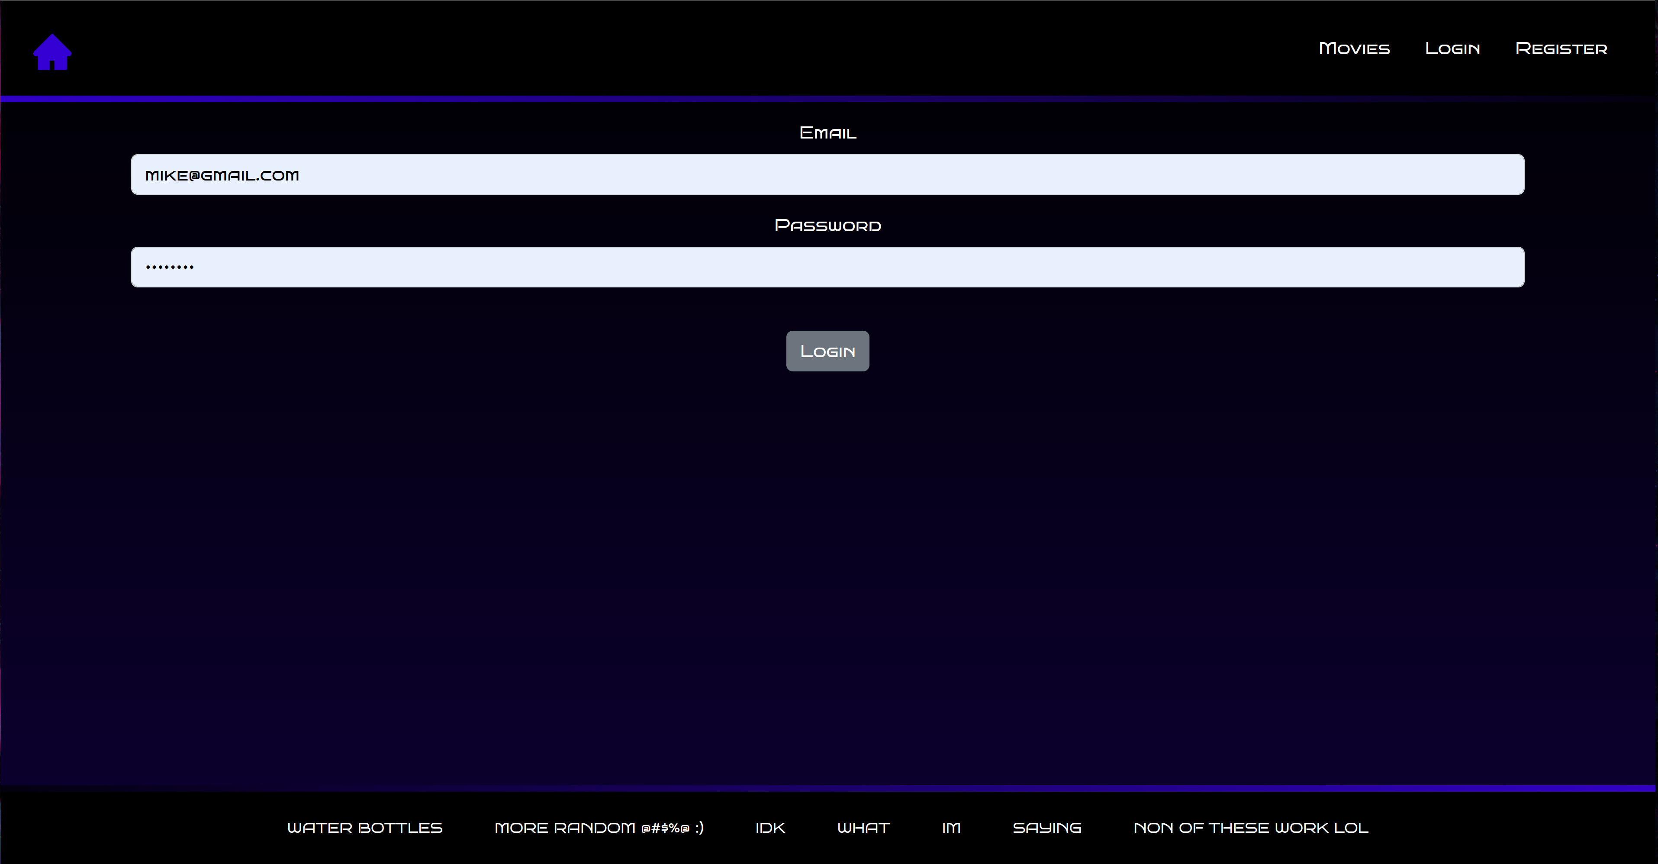
/user/refresh
This endpoint does not have an associating page on the website as its used in the background away from the users knowledge. The Refresh endpoint is use to get new authentication tokens so that when the bearer Token expires they do not need to login with would occur every 10 minutes otherwise. This allows for a better user experience and better security as tokens are constantly changing.

/user/logout
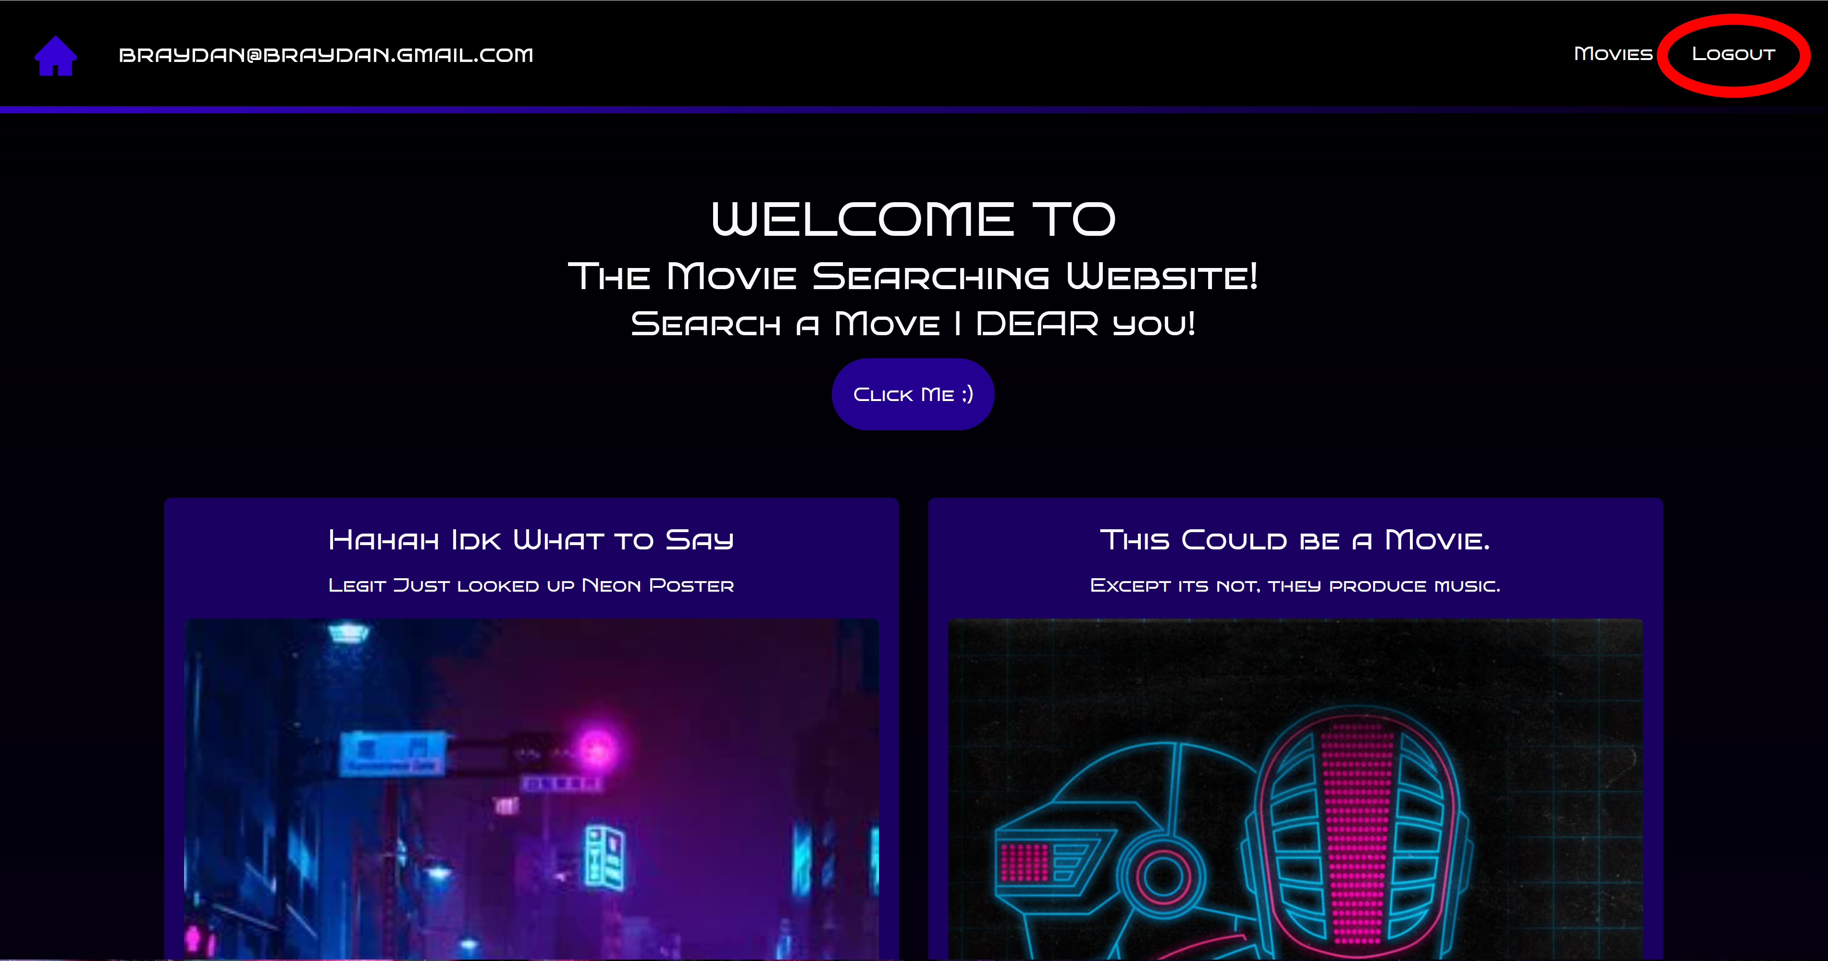
This endpoint does not have an associating page more of a button on the website as its used in the background away from the users knowledge. This allows the user to deactivate the the authentication tokens on there account and also removes all tokens and authentication data from storage.
Modules Used

ag-grid-react
Module to provide fully-featured table components
https://www.ag-grid.com/react-grid/

reactstrap
Module to provide all the bootstrap capabillities in a react app
https://github.com/reactstrap/reactstrap

chart.js
Module to provide the abillity to easierly add charts componets to react
https://www.chartjs.org/

MUI
Module to provide a lot of different icons that are easy to customise
https://mui.com/

Application Design
Navigation and Layout

The layout of this site aims to allow the user to navigate the site efficiently and effectively, guiding them though each available endpoints in succession. The beginning of this flow starts at the homepage where a navigation bar, cards are displayed to add style to the application. The main function of the homepage is to provide the user with a point of access to the movie page via the browse button. The part of the website that is the main focus is the movie and people information sections, to get there you enter the movies list view. This is where you can select any move you choose and to narrow down the search you can Search by text in the title and year of release. After selecting a movie you can go on to see the movie information page. In this view of the movie
Wire frames:

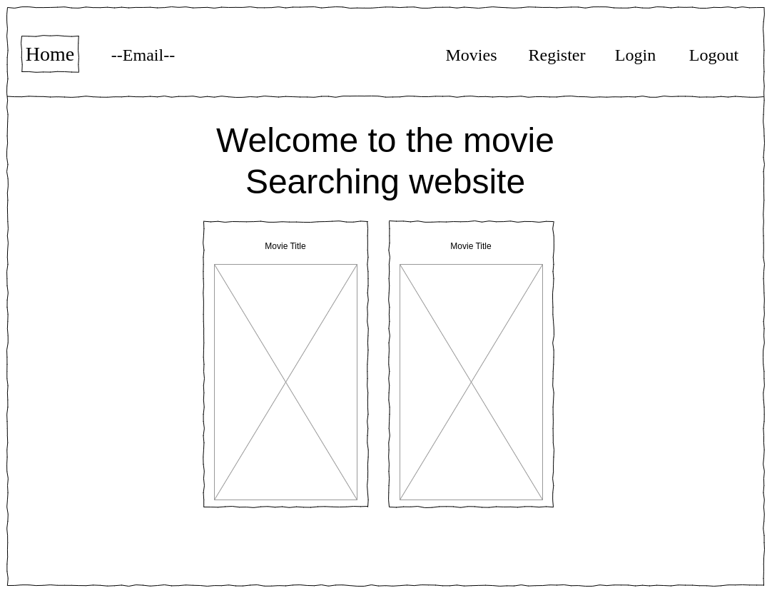
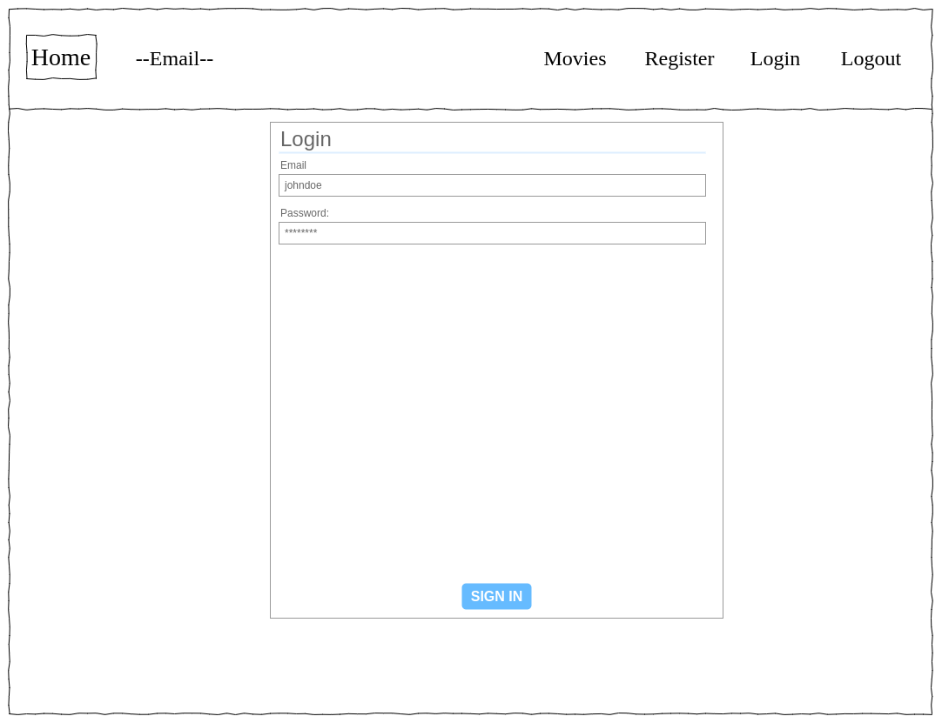
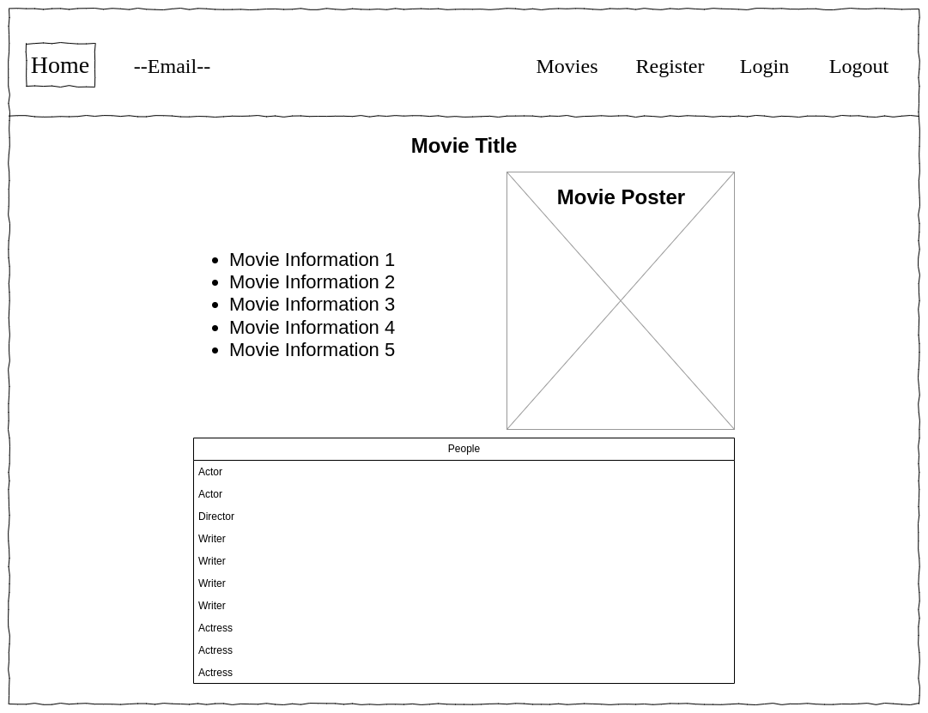
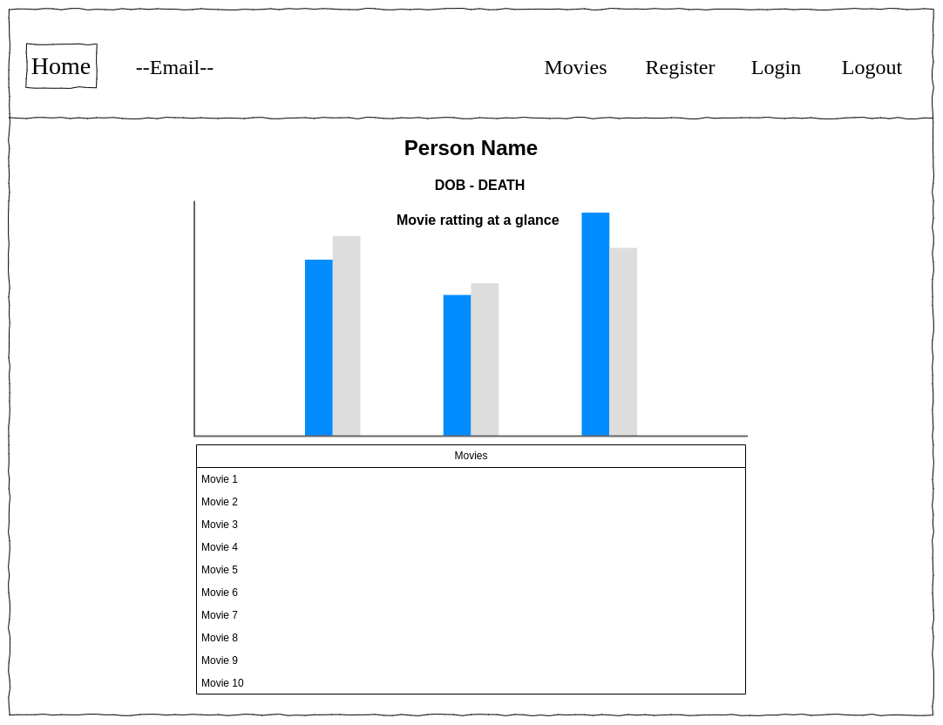
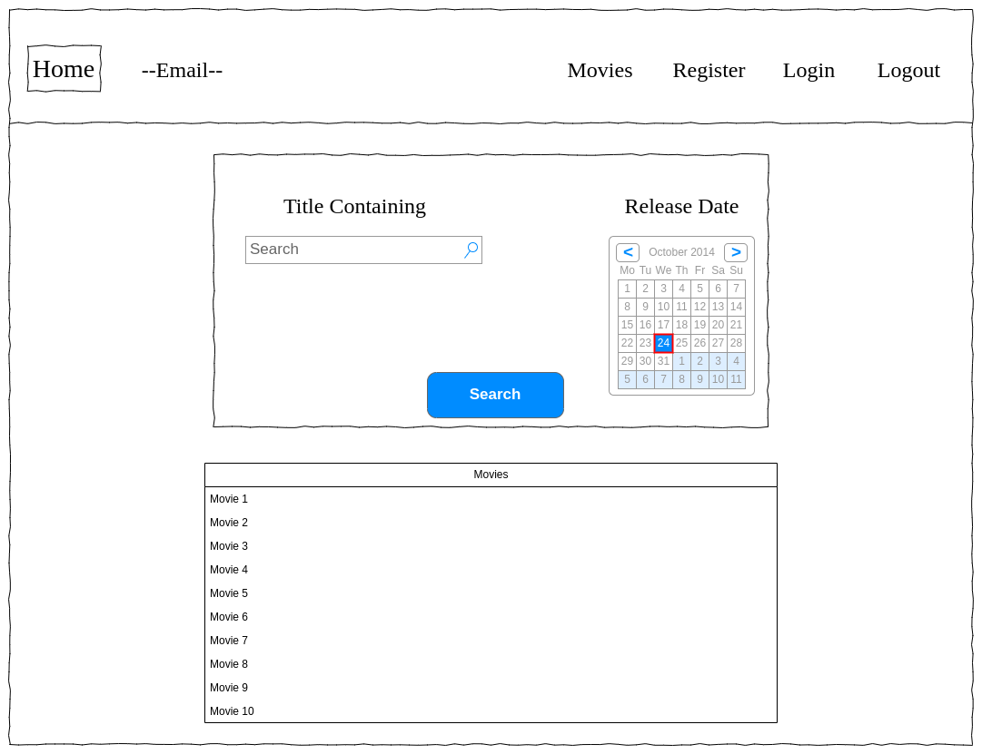
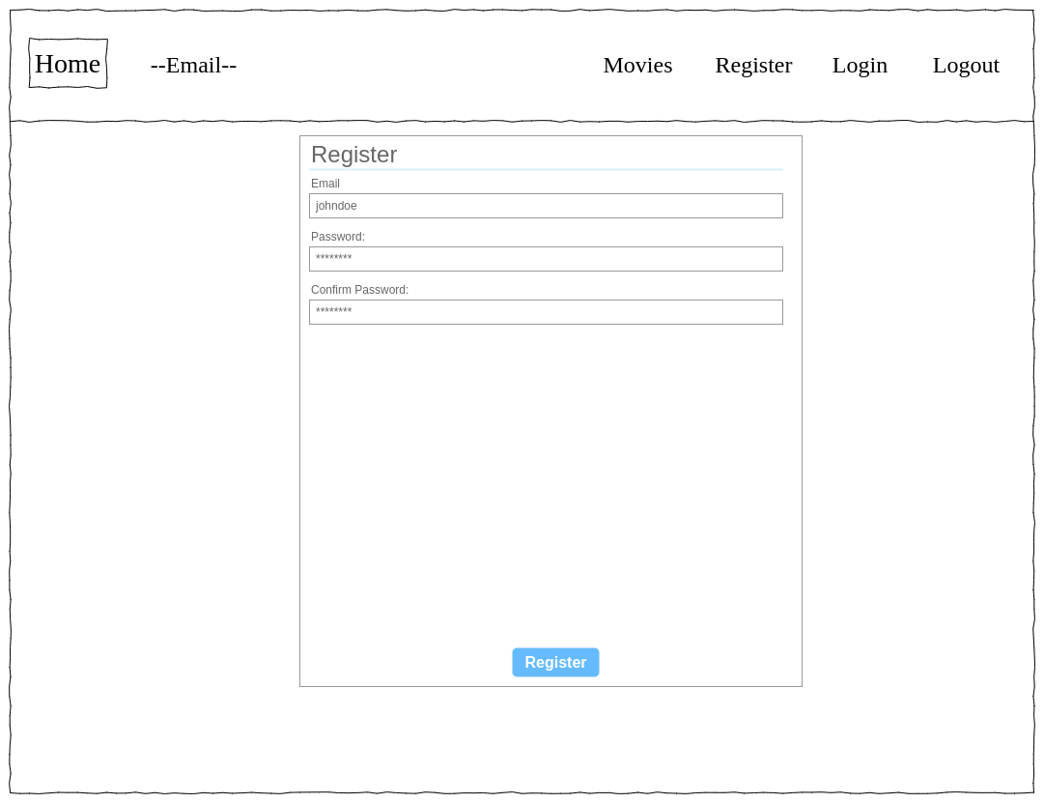
Usability and Quality of Design

In general id say the design is well organised with a simple clean layout. For each page the relevant information is shown clearly with good spacing to distinguish between all the information. Due to the limited button in the nav bar and thorough out the site with only the navigation that are really needed with good labelling, id say the navigation is clear and intuitive. The things taken for grantered on websites have been implemented here like the home button in the top left taking you back to the home page. In terms of visual consitancy, the colours, and basic layout do not change from page to page. There are only 5 coulours used in the site and where cossen for a clear dark atesthtic with a calming theme. A single font is used on the site not to confuse readers. The userbillity of my design is fine for any normal visitor. However the AG grids do have the majority of the styling issues where they are not the correct colours, not the correct size and conffigered wrong thus having the wrong column size.

Accessibility
- Provide a text equivalent for every non-text element – alternatives to images, symbols, scripts, graphical buttons, sounds, audio and video files and so on.
  - Every image does have a text representation, how ever this text is not very descriptive of the image and is limited to “poster” or something similar
  - The icons/symbols do not have text representations
  - This is hard to do when you are creating a site with procedural/dynamic content
- For tables, identify row and column headers – clearly differentiated from the data.
  - This is done by default with AG grids and there themes.
  - This makes the grid lists far more readable and easy to see rows and columns
- Avoid causing the screen to flicker.
  - This is mostly eliminated due to all main backgrounds being the same dark colour.
  - This could occur if the styling is removed

Technical Description
Architecture
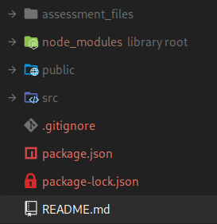
The layout of my project structure is a vary normal Node React Application apart form the “assessment_files” folder which holds document specifically for the written part of this assessment

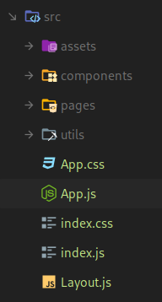
The src directory is laid out in a very standard way with with each folder containing only files that relate to a given task. Such as all files in the components folder are all single parts of a page like the nav bar or footer. The app and index files in the root src directory are the base of the react application. The app.js file contains all the routing for the site so different URL’s map to different pages. The Layout.js file describe the default layout of the page with the header at the top, footer at the bottom and the and the main content like movie list in between.

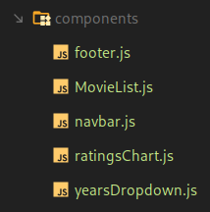
The components folder holds a bunch of components that could be reused thorough out the application without needing to be re written just imported. Things like year date drop down and the nav bar.

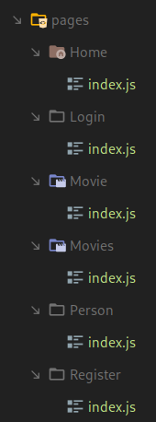

The pages folder holds the content part for each individual page such at the movie list page, it describes how the page looks and puts all the parts of the page together. These pages get the data from the utility functions which will be explained later, form there the data is then parsed and split up with JSX.

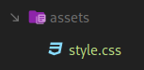
The assets folder holds all extra files the application will need in this case it holds an extra style sheet for more styling on top of the App.css one.

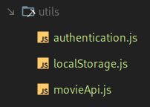
The Utilities folder holds a collection of javascript files with function to help to various things like get all the data for the movies and people. The authentication.js file handles and deals with the fetch requests for all authentication requests such as login, logout and refresh. While the localStorage.js file handles all the writing and reading from local storage, and json parsing and stringifying the objects. The MovieApi.js file handles the retrieval of all the movie and person data, while also dealing with all the different responses that could be sent back.

In summary I chose to split the application structure like this so that it would be easy to reuse code and be self explanatory on what each file and folder is used for. Making it easier for debugging and building on this website in the feature.

Test Plan

Task | Expected Outcome | Result | Screenshot/s (Appendix)
Show a list of default movies | Shows a list of movies | PASS | 01
Search for movies with a specific year release | Shows movies with specific year release | PASS | 02
Search for movies with specific text in the title | Shows movies with specific text in the title | PASS | 03
Search for movies with a specific year release and text in the title | Shows movies with a specific year release and text in the title | PASS | 04
When selecting a movie from the list, should show a page with information about the movie and a list of all the people associated with the movie. | Takes you to a page about the movie and has a list of people | PASS | 05
When selecting on an person, should take you to a page to view information about the person and there career | Takes you to a page about the person and has a information about there career | PASS | 06
When Viewing a persons career should also show a quick glance chart of the persons movie ratting | Shows a table of the collated results from rating of all the movies they worked on | PASS | 07
When trying to register an account it should check that the email is a valid email. | When checking an email will stop the user form proceeding any further till email is valid | PASS | 08
When trying to register an account it should check that the password and confirmation password are the same before proceeding | When checking apassword will stop the user form proceeding any further till both passwords are the same | PASS | 09
When register is complete it should log me in also | When register is done the site will log you in as well | PASS | 10
When register or login is finished, should take you back to the page you came from | When finished login or register will take you back to page pervious | PASS | 11
When trying to access data from a authenticated endpoint and auth fails, it should attempt to refresh the tokens | When accessing the data with an expired token it refreshes the token and tries to fetch the data again | PASS | 12
While logged in the user should ne be able to see the login and register buttons, and only a logout button and vice versa | While the user is logged in only the logout button is visible and before logged in the only the login and register button | PASS | 13
When scrolling down in the movie list, once bottom is reached should request more results to create infinite scrolling | The movie list does not fetch more data from the api | FAIL | 14

Difficulties / Exclusions / unresolved & persistent errors

The only roadblock I ran into was just learning how react works and moving from the Vanilla Javascript I am use too. After reading the react documentation it was pretty simple to put together this simple application. I was not able to get the infinite scrolling on the movie list, this was due to time constants and the documentation not explaining real world examples. The only bug I can think of would be the lack lustier styling and the ag grids being not themed correctly.

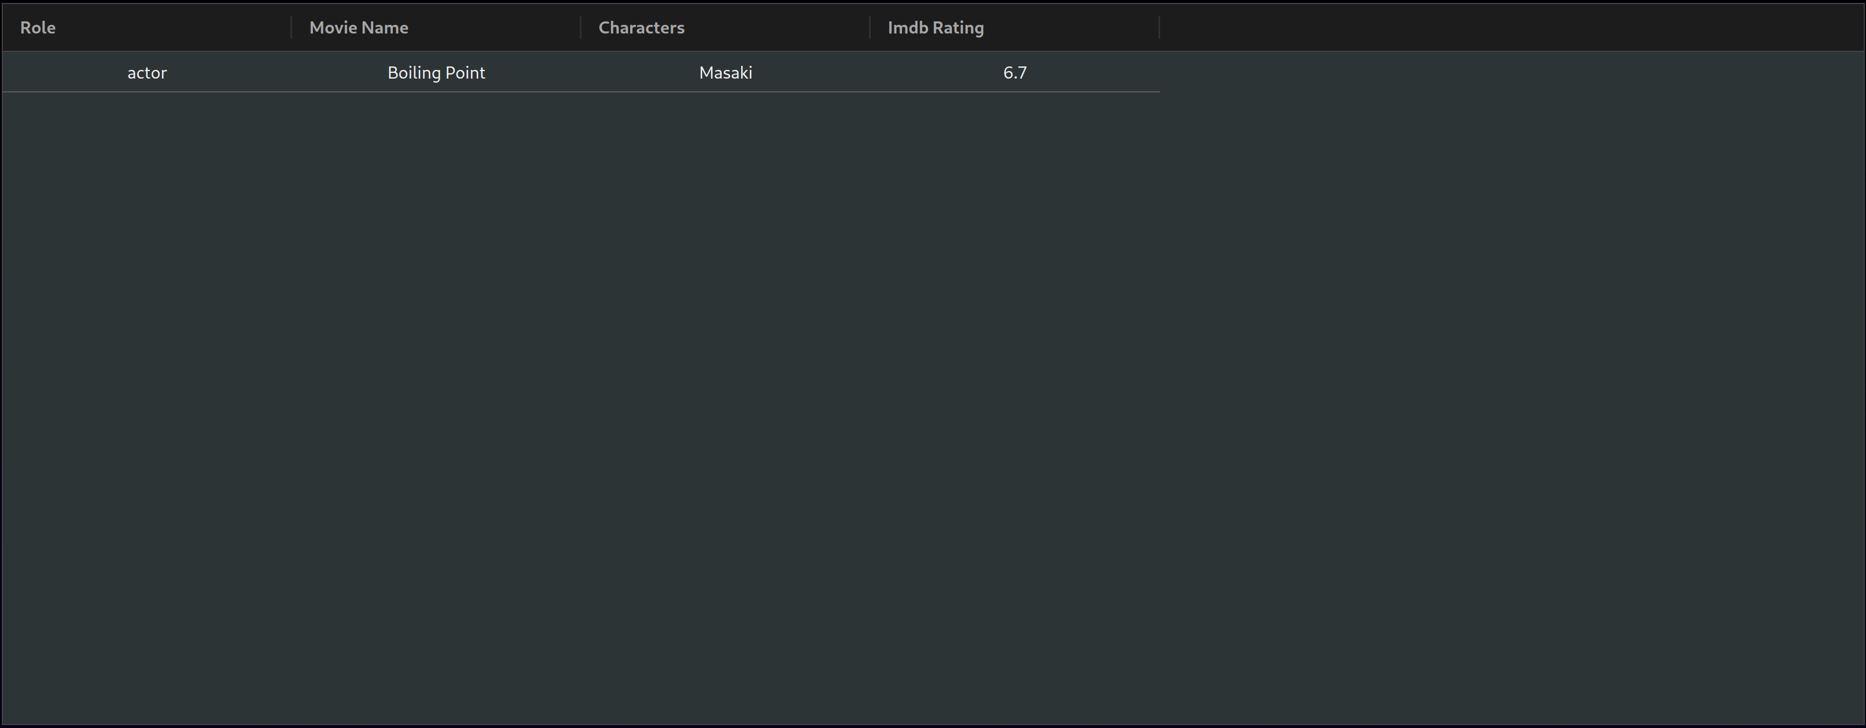

User Guide
Home Page:
From here you can see all the options at the top in the nav bar, this will be present on all pages to make navigation easy. From here you can log in register and go to the move searching pages.
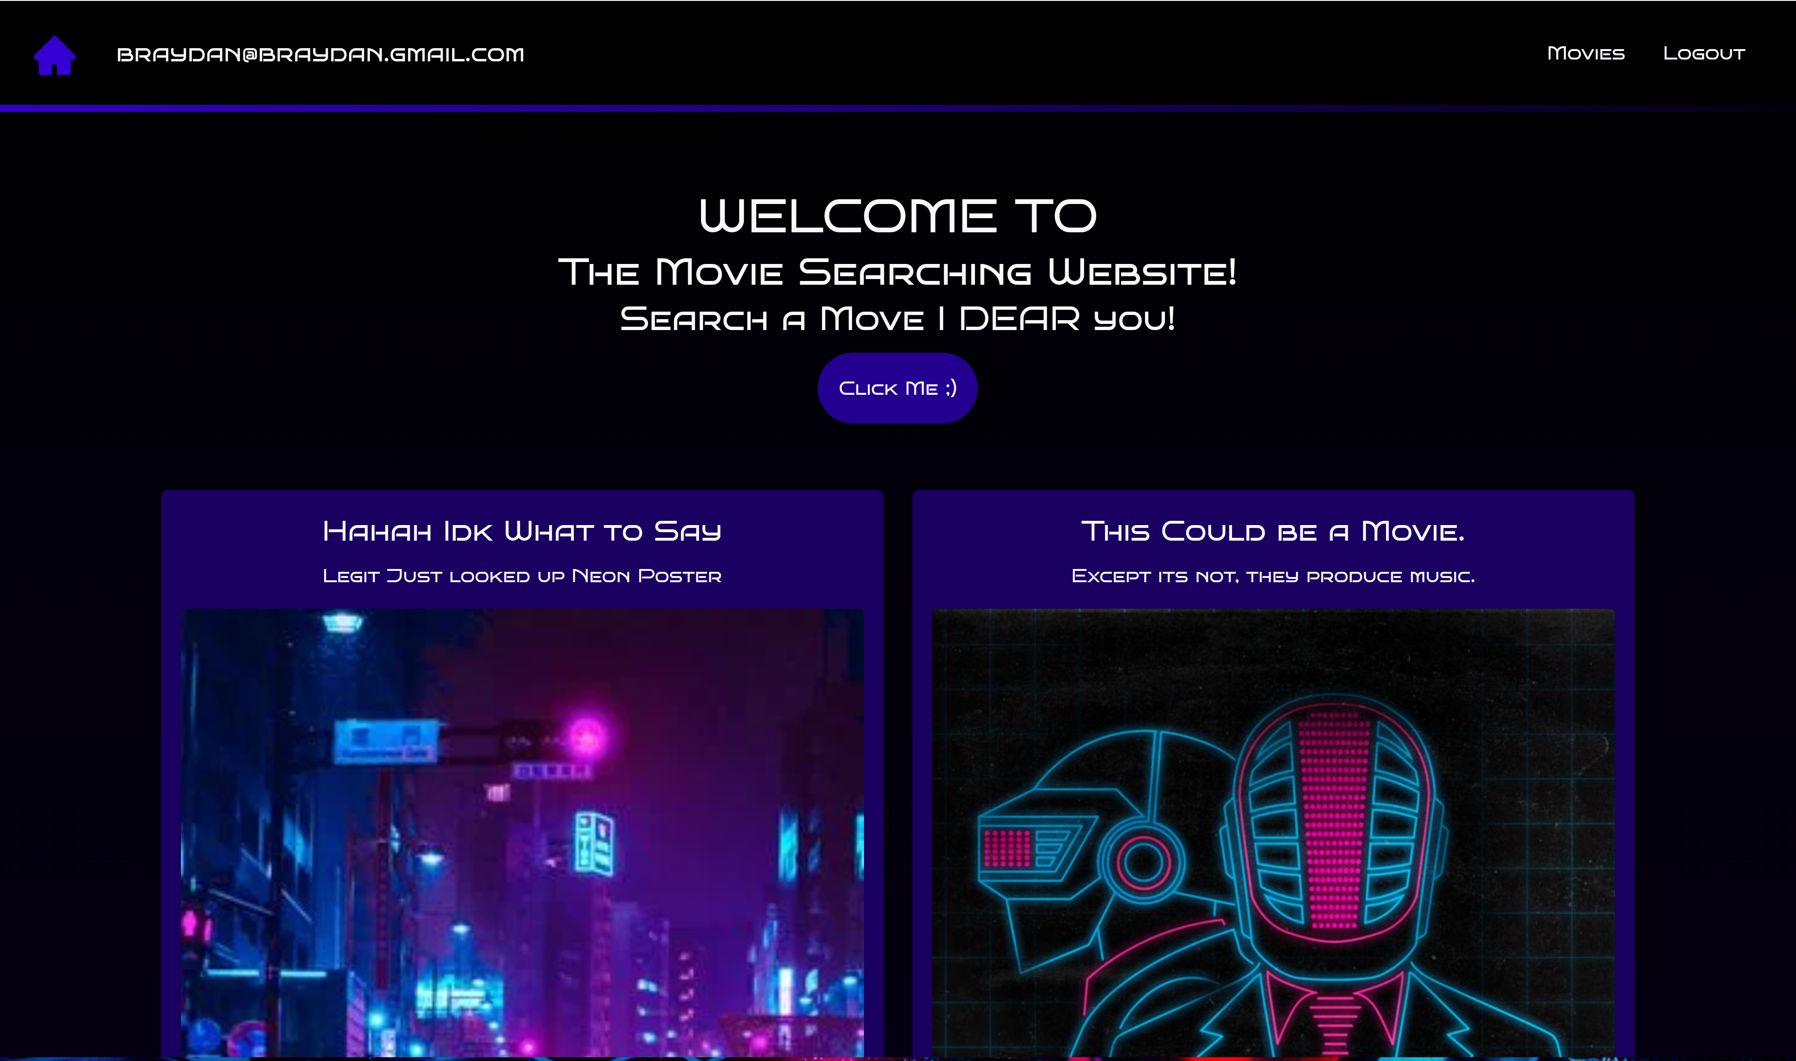

Register:
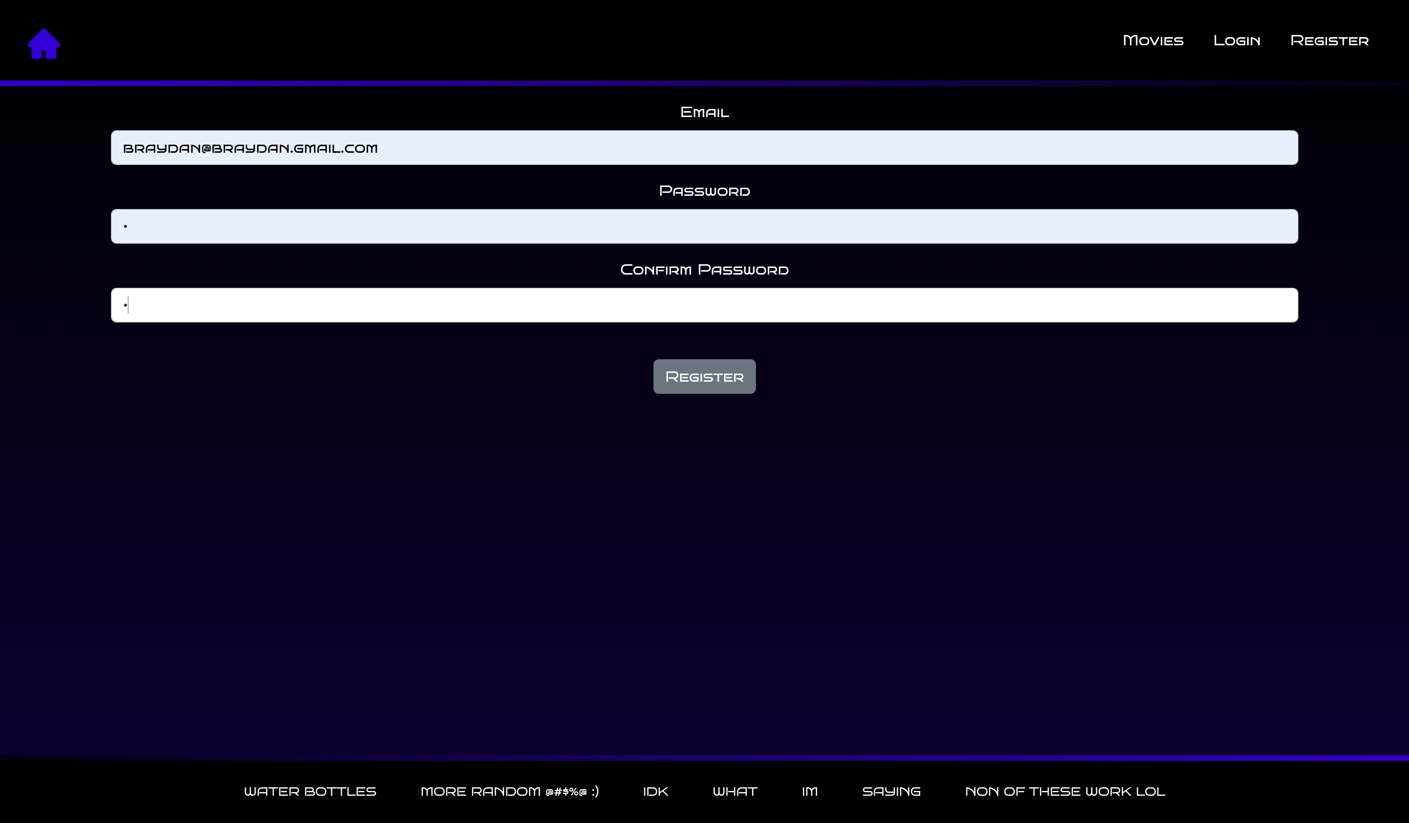
The register page is where you go to make an account. From here you need to enter a valid email and a password assuring that both password field have the same text in them. Once this has been done clicking the register button will create an account and log you in at the this point youll be put back on the page you when to the register page from.

Login:
The login page is where you go if you are not logged in but already have an account. From here you enter you password and email, if valid then you be logged in and put back to the page you came from.
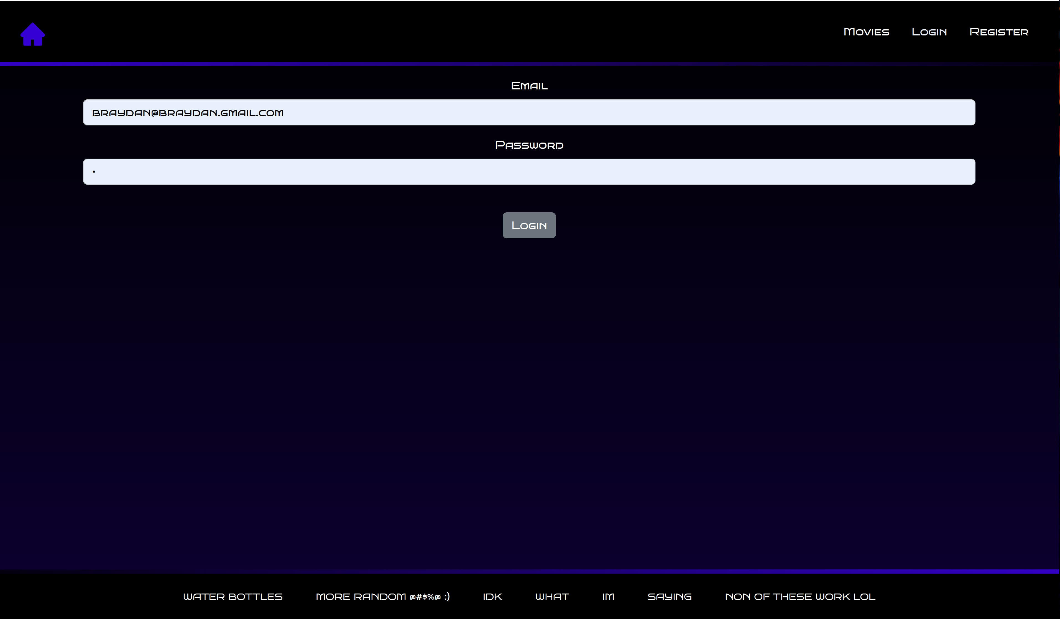
Movies Searching
On this page you will be presented with an form to put in search parameters, and a list of default searched movies. Tying in text in the search field and searching will preset only movies with the text somewhere in the title and changing the date and searching will search for movies with this release date. By click on a movie in the list you can go to more information about this movie.
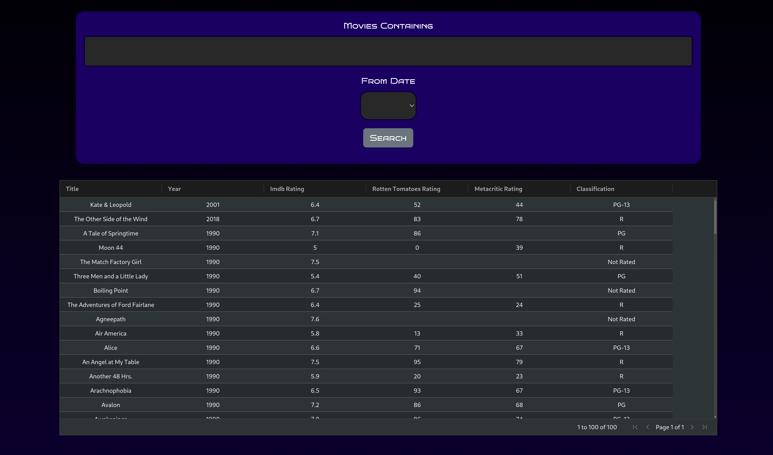
Movie Information:
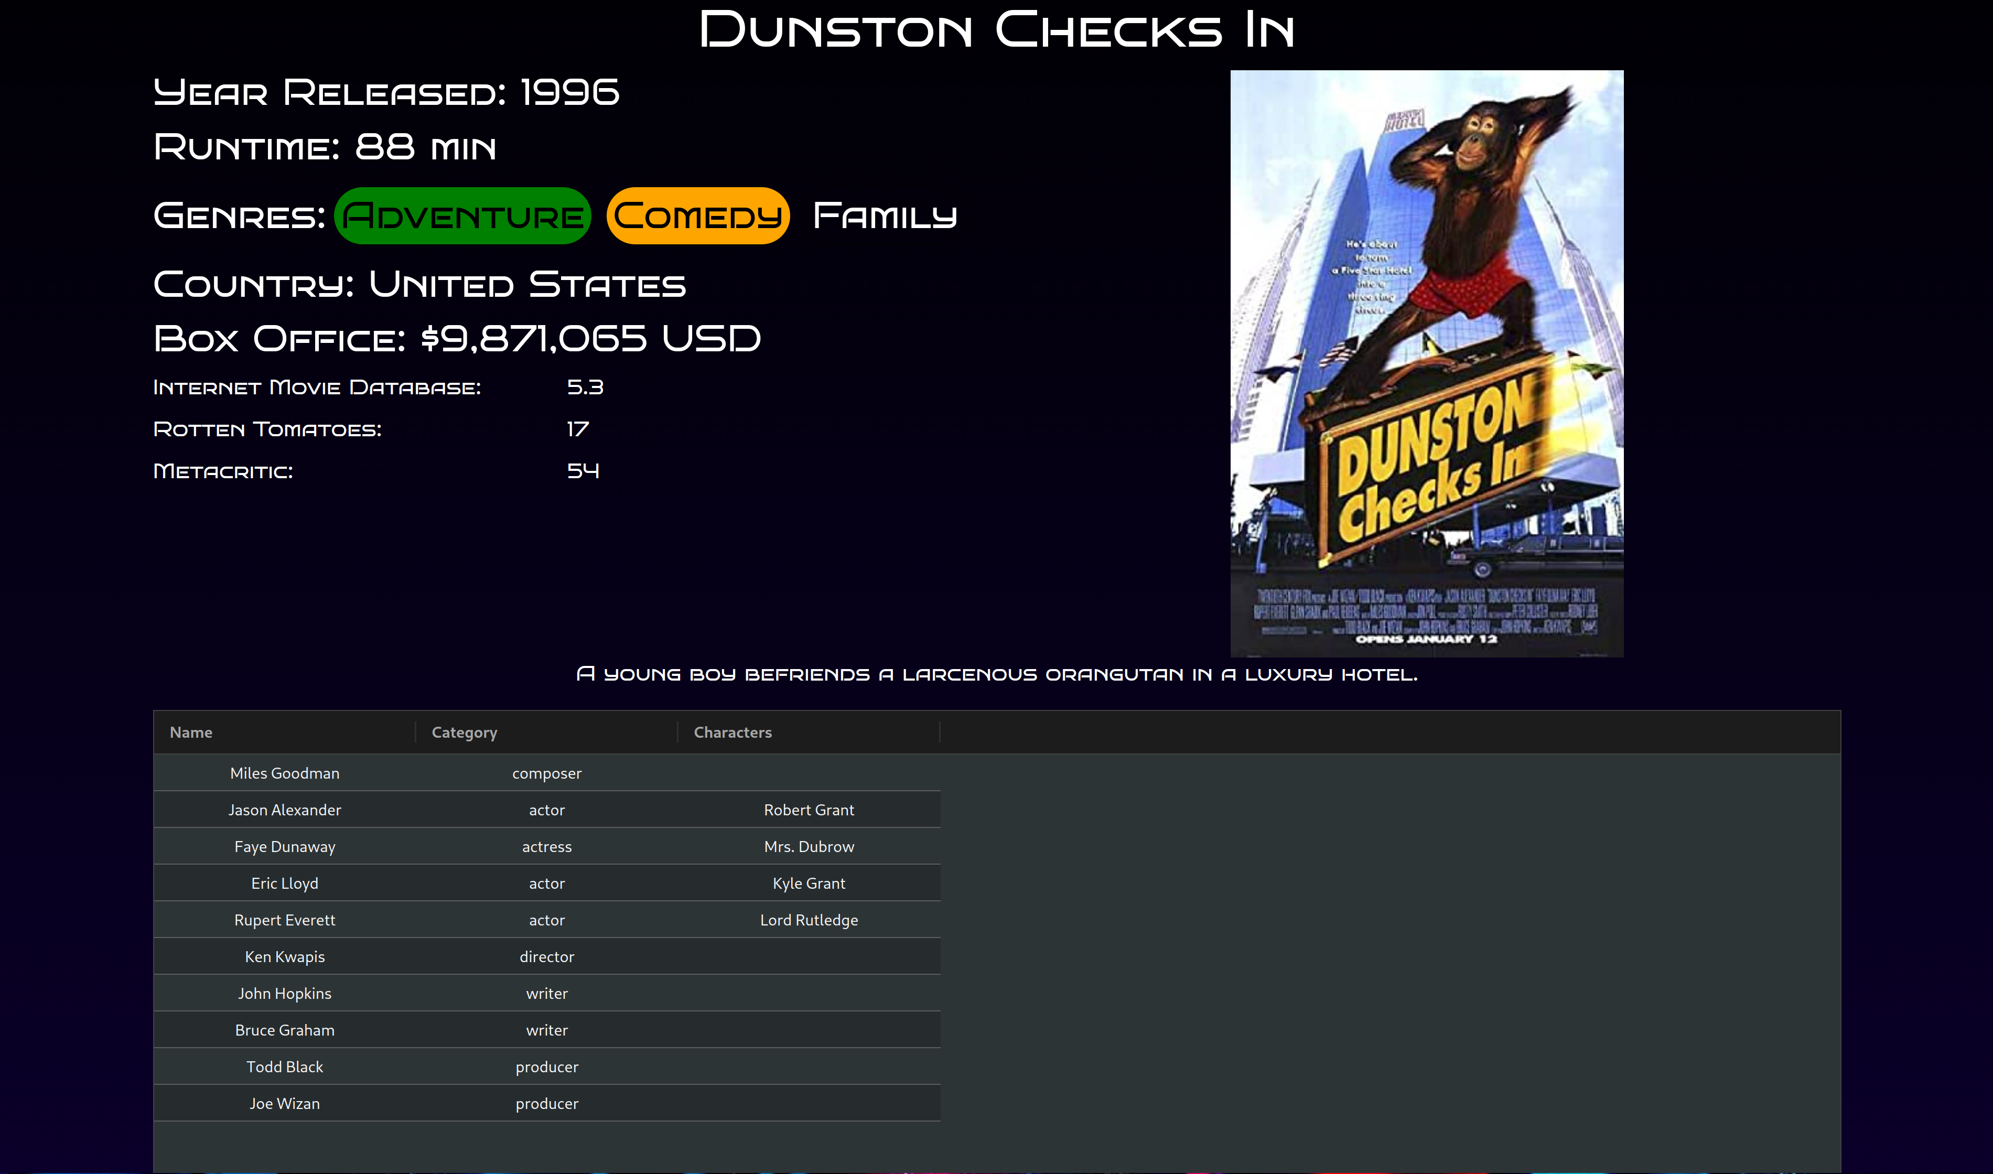
On this page the movie you selected on the movie list page will be shown with extra details about the movie, giving you easy access to the information about this movie, along with a list people associated with movie like actors director and writer. Clicking on a person will take you to a page with more information about this person.

Person Information:
On this page you will have to be logged in with a non expired refresh token. From here you will be presented with a a bit of information about the persons movies career like a graph of the collated movie ratting the person was apart of and a list of the movies they were apart of, by clicking one of these movies you will be taken back to the movie information page about that movie .
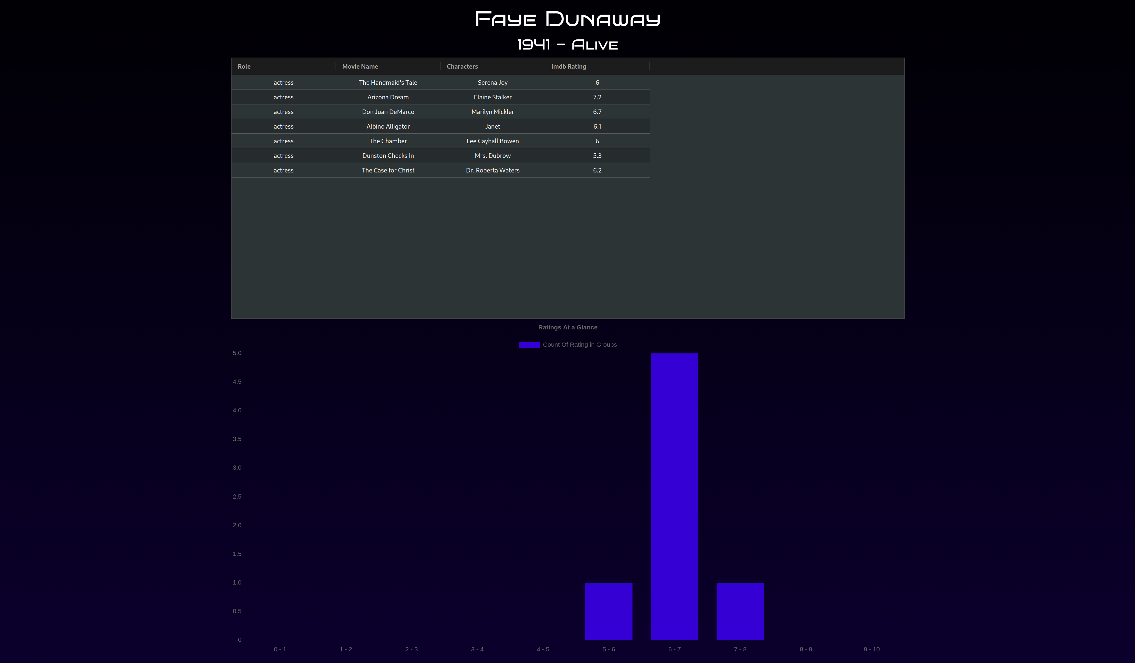
Logout:
By clicking the logout button in the nav bar you will be logged out of your account and taken to the home page.
References
Chisholm, W., Vanderheiden, G., & Jacobs, I. (Eds.). (n.d.). Checklist of Checkpoints for Web Content Accessibility Guidelines 1.0. World Wide Web Consortium (W3C). https://www.w3.org/TR/WAI-WEBCONTENT/full-checklist
React. (n.d.). https://react.dev/

Appendix

Screenshot 1
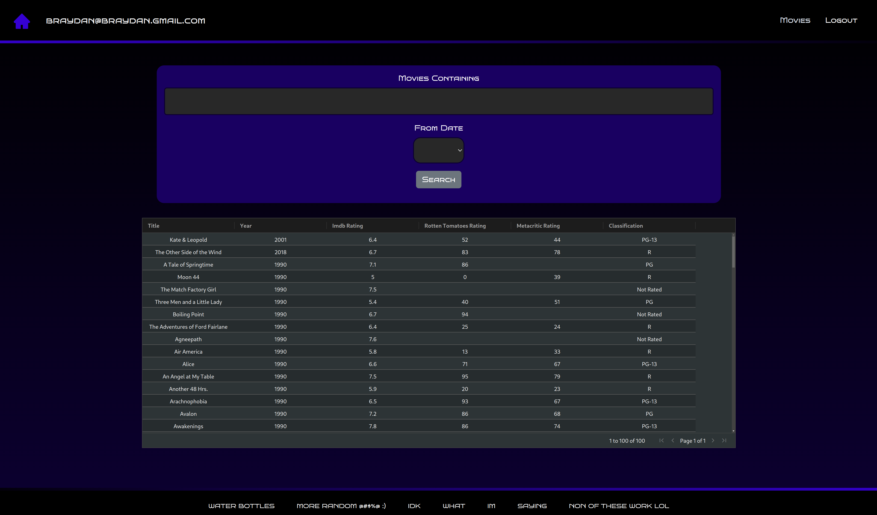
Screenshot 2
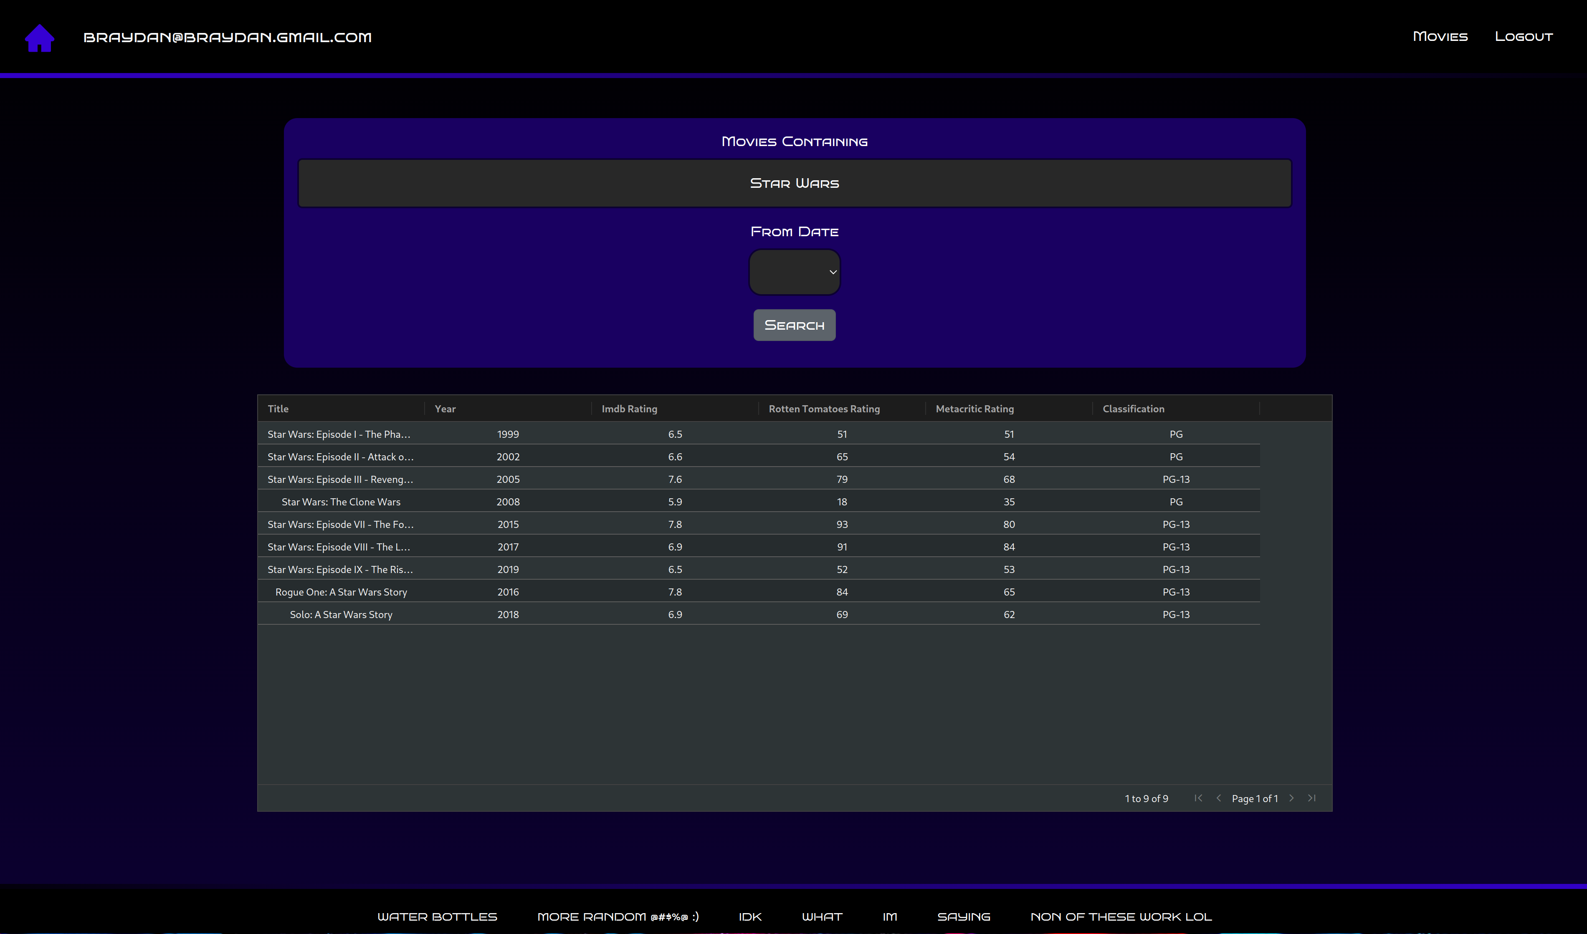

Screenshot 3
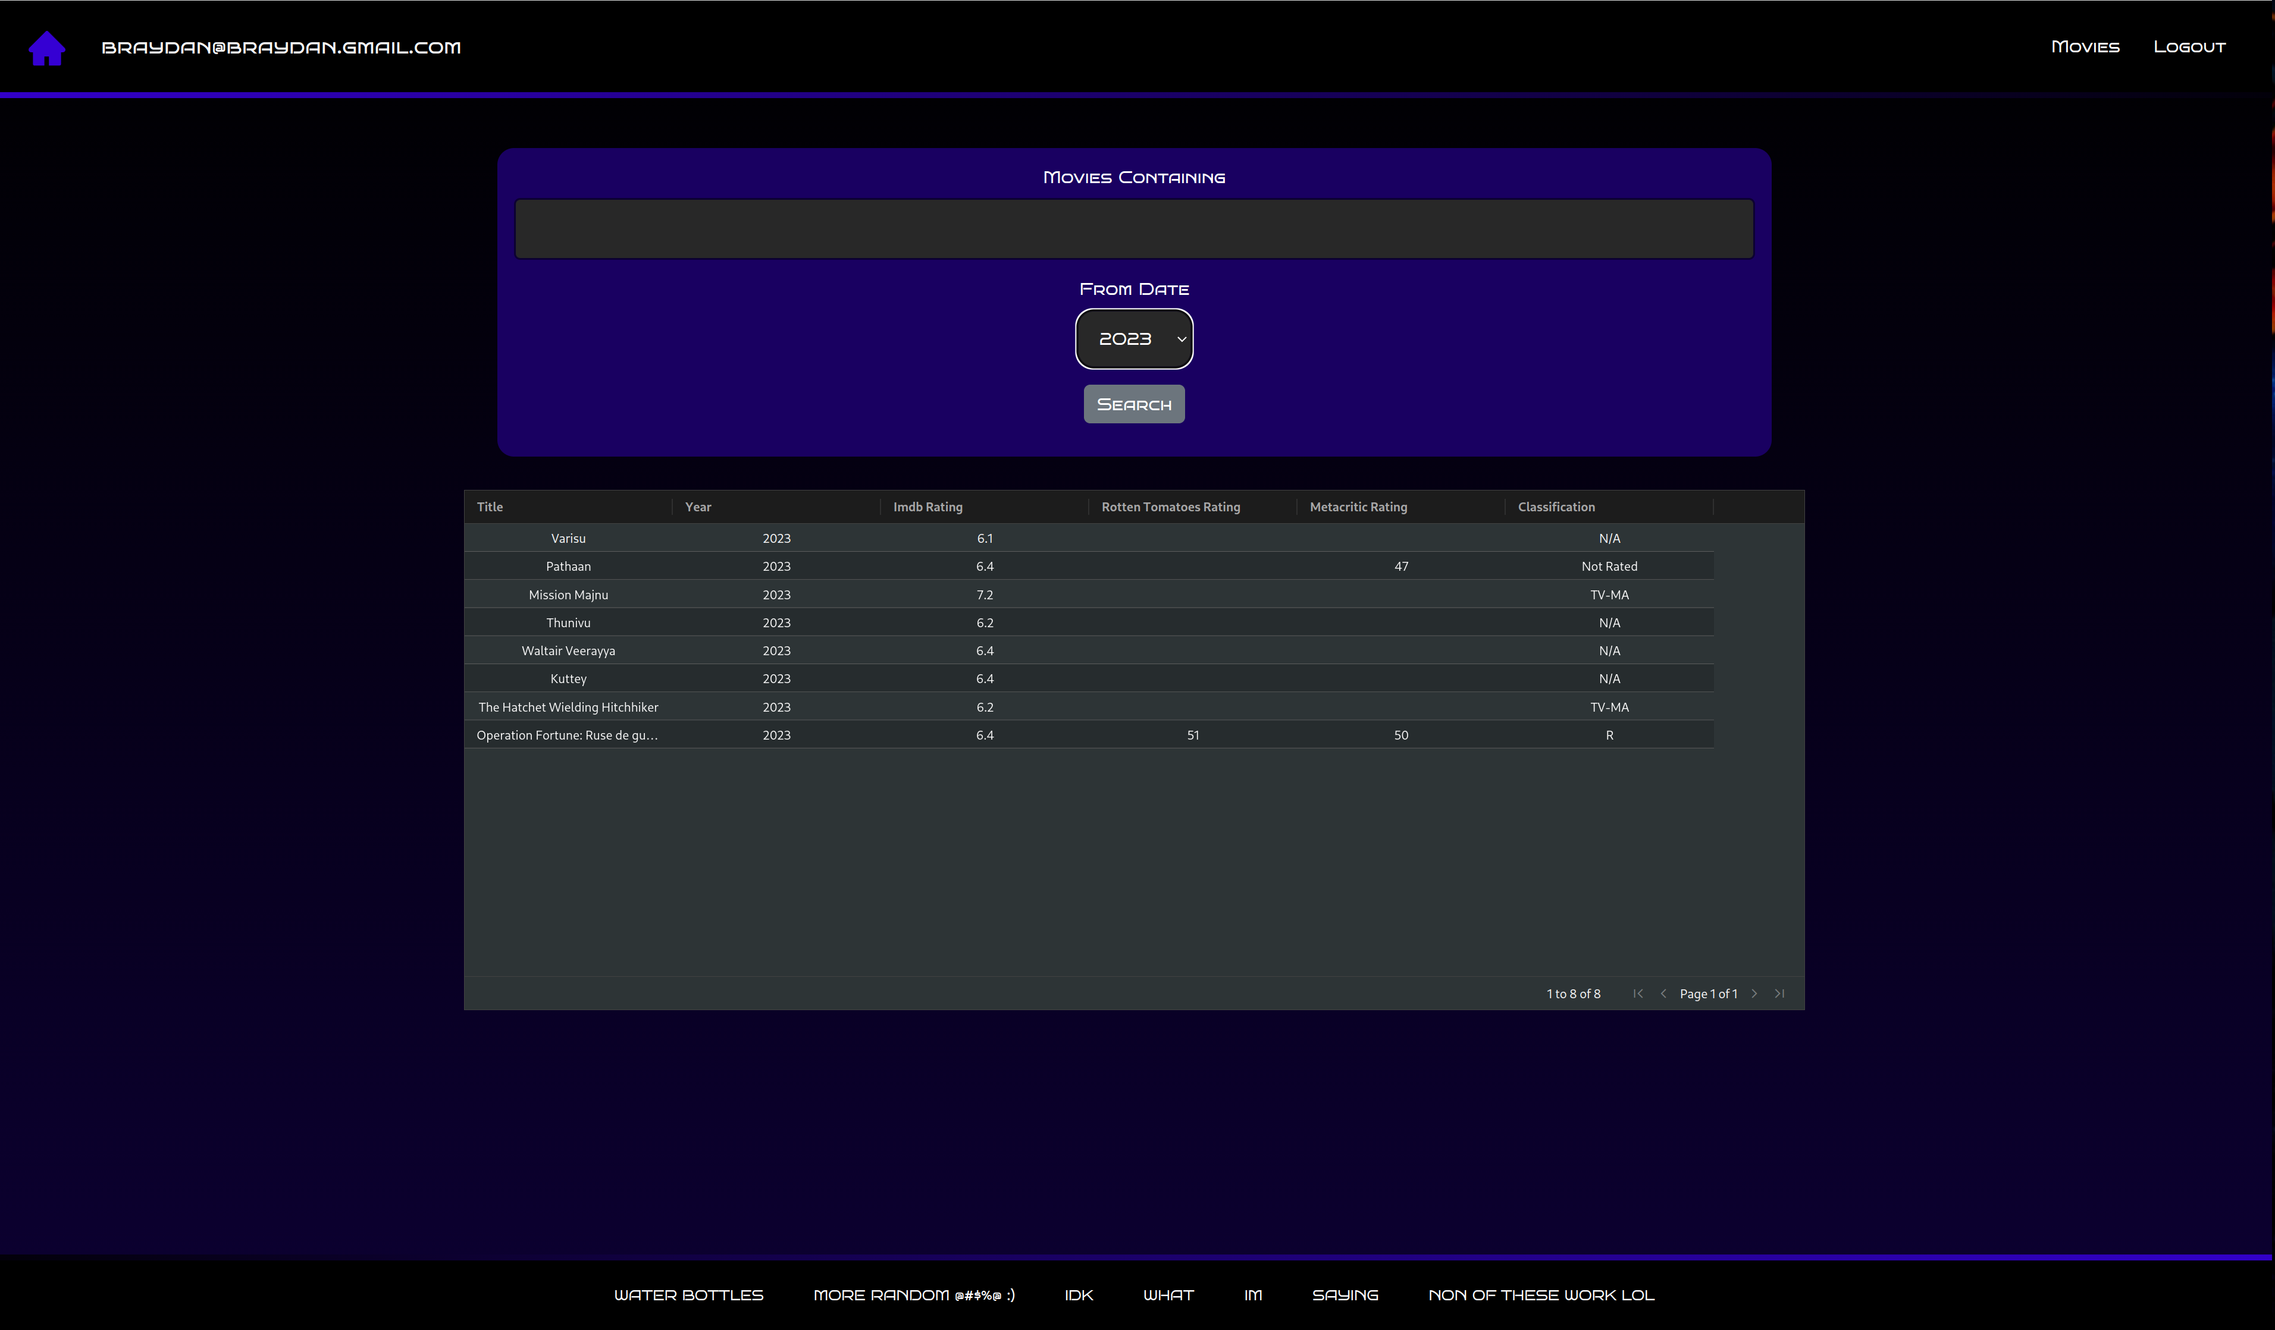
Screenshot 4
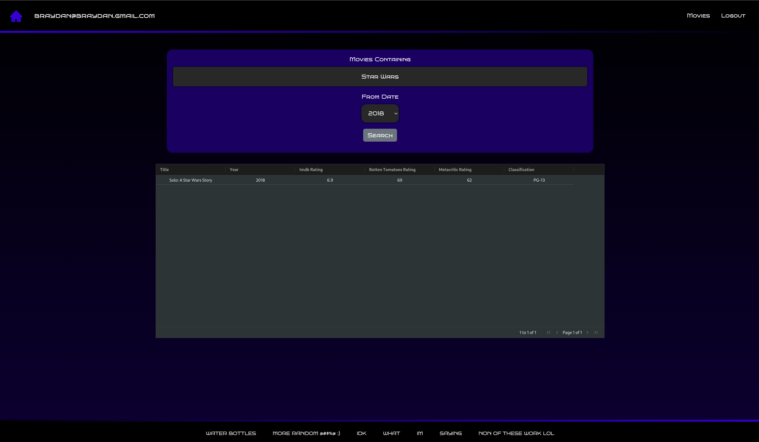

Screenshot 5
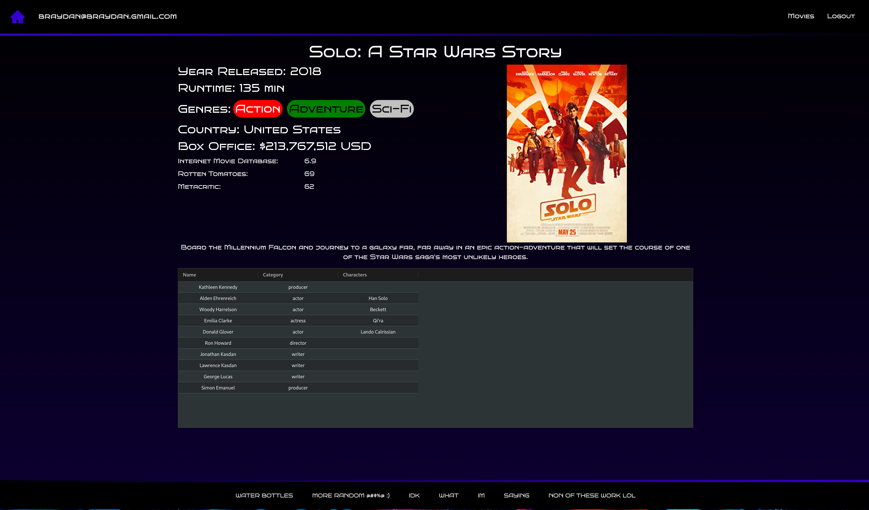
Screenshot 6
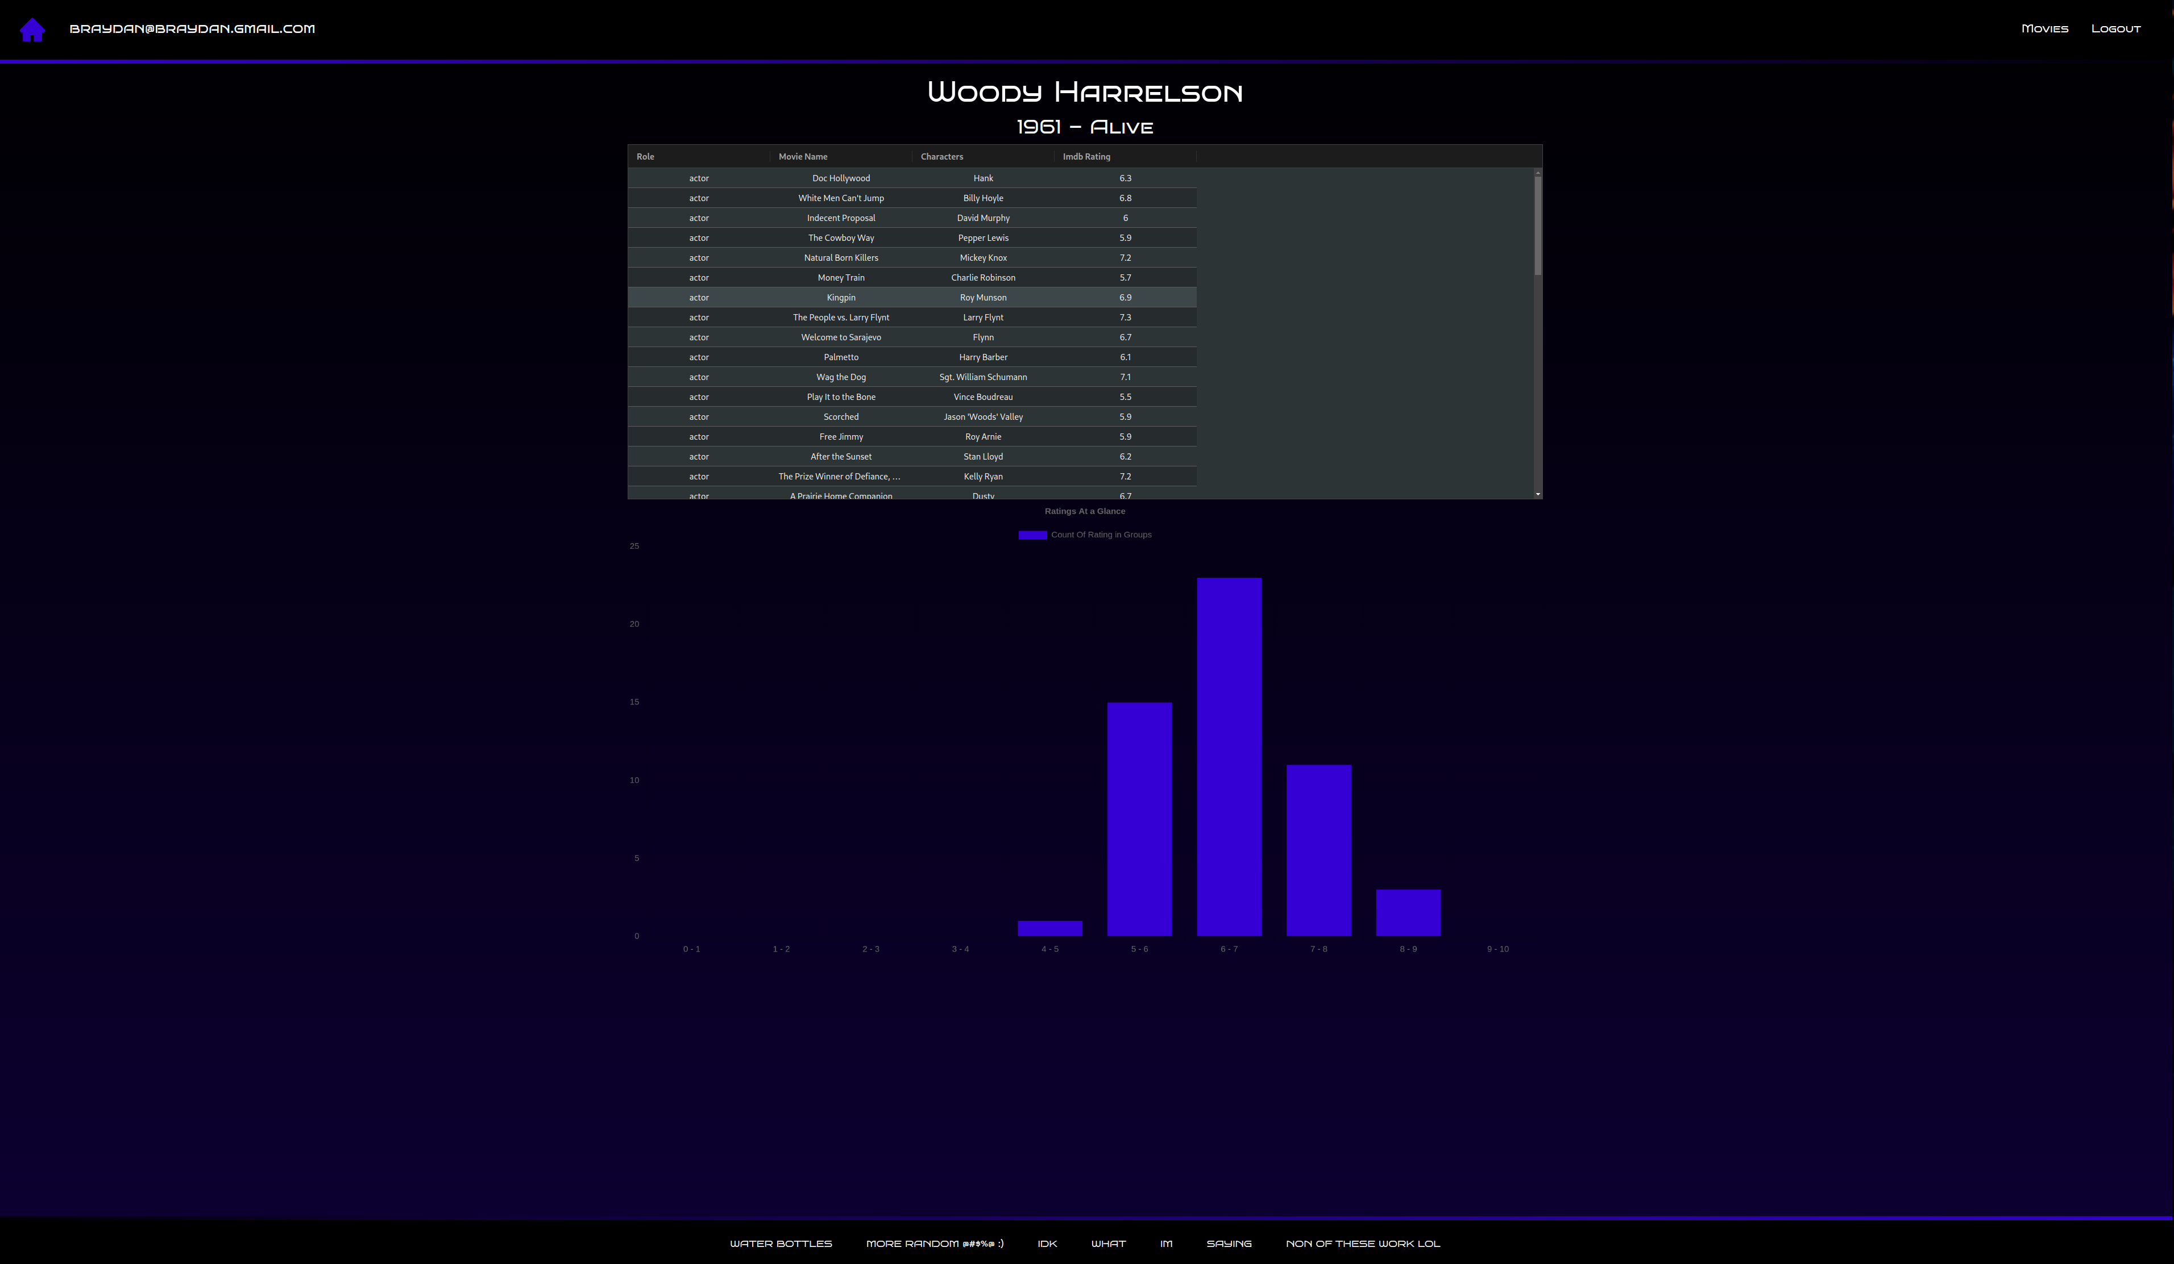

Screenshot 7
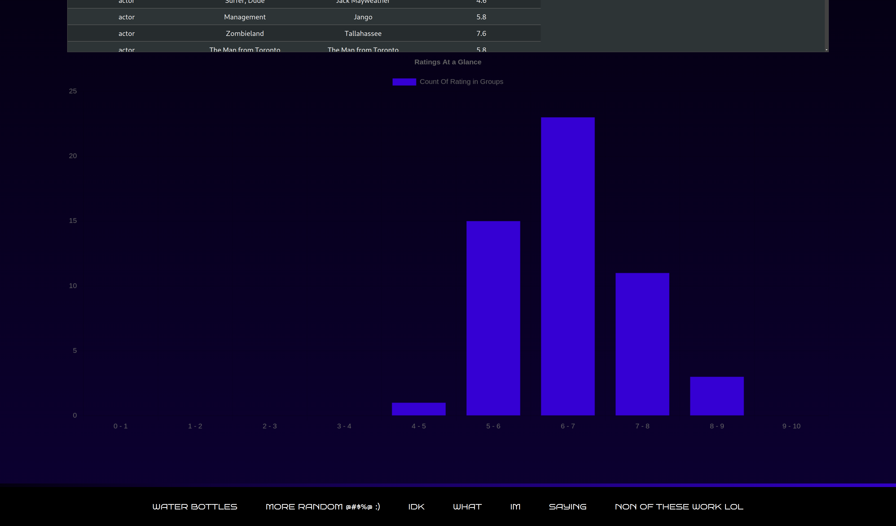
Screenshot 8
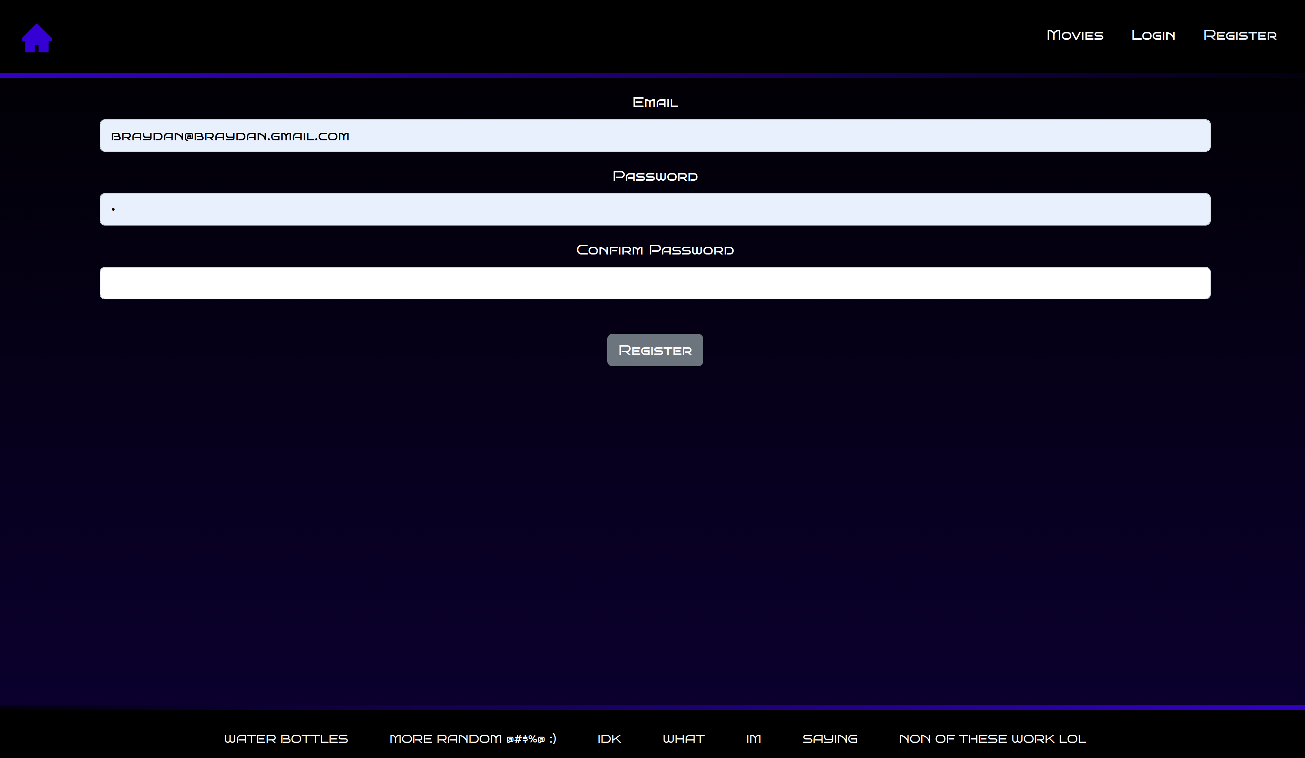

Screenshot 9
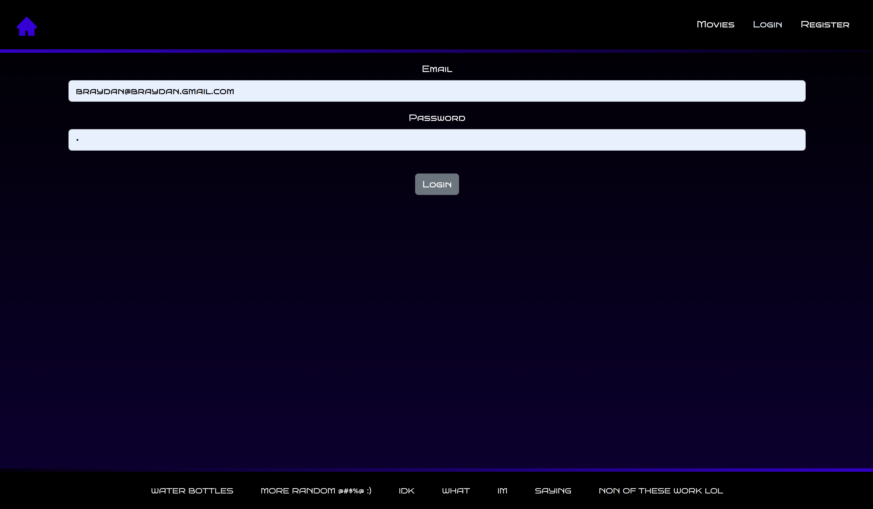
Screenshot 10


